Masterproject Documentation

to the topic

Title of the work

presented to the Faculty of Computer Science
of the University of Duisburg-Essen

by
First-name Last-name
Address
Postcode City
Matriculation number …

Reviewer: Name of the 1st reviewer
Name of the 2nd reviewer

Semester of study: …

Table of Contents
List of Abbreviations III
List of Figures IV
List of Tables V
1 Abstract 1
2 Introduction 2
2.1 Background 2
2.2 Problem definition 2
2.3 Objective 4
3 Fundamentals 5
3.1 Theoretical background 5
3.1.1 Data Management 5
3.1.2 ML-based Models 5
3.1.3 Dashboard 5
3.2 Current state of research 6
4 Methodology 7
5 Conception 8
6 Implementation 9
6.1 9
6.2 ML-Models 9
6.3 Dashboard 9
6.3.1 Introduction & Basic Set-up 9
6.3.2 Design Creation 10
6.3.3 Overview Dashboard (Semih) 12
6.3.4 Geographical Overview (Alex) 14
6.3.5 KPIs (Semih) 16
6.3.6 Additional KPIs (Sarah) 17
6.3.7 ML-based Predictions (Alex) 24
6.4 24
7 Findings 39
8 Discussion and conclusion 40
8.1 Summary of the findings 40
8.2 Interpretation of the findings 40
8.3 Limitations and future research 40
Bibliography V
Appendix XII
Appendix 1< Title of the first appendix > XII

List of Abbreviations
AI Artificial intelligence
IT Information Technology

List of Figures
Es konnten keine Einträge für ein Abbildungsverzeichnis gefunden werden.

List of Tables
Es konnten keine Einträge für ein Abbildungsverzeichnis gefunden werden.

Abstract
Short summary of the document (incl. Goal, Method, Solution and Conclusion)

Introduction

Background
Supply Chain Management (SCM) emerged in the 1980s as a response to growing global competition, shorter product life cycles, and rising customer expectations (Oliver & Webber, 1982; Houlihan, 1985). Unlike traditional approaches that focused primarily on internal logistics or supplier management, SCM emphasizes the coordination of end-to-end processes across multiple organizations from raw material suppliers, through manufacturing and distribution, to the final customer. Hewlett-Packard’s early work on supply chain methodologies illustrated how uncertainty in supplier reliability, production, and transportation can propagate across networks, leading to inefficiencies, excess inventory, and lost sales (Davis, 1993). Effective SCM therefore requires not only managing individual functions but optimizing the system as a whole.
A central insight in the field is that competition increasingly occurs not between individual firms but between entire supply chains. Christopher (1992, 1998) argued that customer value is determined by the performance of the entire network rather than by a single firm’s efficiency. This paradigm shift underscores the importance of collaboration and information sharing across organizational boundaries. Modern supply chains are also characterized by extreme complexity: large manufacturers often rely on thousands of suppliers across multiple tiers and geographies, making coordination and transparency essential (Sucky, 2021). In this context, SCM has become a cornerstone of industrial management, providing a strategic framework for enhancing efficiency, reliability, and customer satisfaction in interconnected and uncertain environments.
SCM has since developed into a multidisciplinary field, drawing from industrial economics, systems theory, marketing, and inter-organizational behavior. Scholars emphasize that addressing supply chain challenges requires contributions from multiple perspectives (Croom, Romano, & Giannakis, 2000). More recent research highlights that supply chains are shaped by key constructs such as uncertainty, coordination, and digital flows, as advances in technology increasingly transform material and information into real-time digital processes (Jodlbauer, Brunner, Bachmann, Tripathi, & Thürer, 2023).
Information technology plays a central role by enabling the collection, exchange, and sharing of data, which is considered one of the critical enablers of collaboration and integration in modern supply chains (Neubert, Ouzrout, & Bouras, 2018). At the same time, the ability of supply chains to respond quickly and effectively to environmental changes, stakeholders, and consumers what Richey, Roath, Adams, and Wieland (2022) describe as the “responsiveness view” has become a foundation of competitive performance, particularly in the face of disruptions. In parallel, bibliometric reviews demonstrate that sustainability, green supply chains, and digital innovations such as blockchain, big data, and artificial intelligence have emerged as dominant themes, signaling how the domain continues to evolve alongside global and technological priorities (Fang, Zhang, Deng, & Shen, 2022).
Modern supply chains now operate within a broader environment that is digitizing, decentralizing, and expanding from linear dyads into “networks of networks,” reshaping how firms coordinate flows, design business models, and compete (Jodlbauer et al., 2023). At the technological frontier, advances such as IoT, data analytics, social data, and additive manufacturing are shifting emphasis from physical flows to information-centric coordination. This enables on-demand customization, prescriptive analytics, and open, interoperable systems—capabilities that enhance responsiveness but also expose gaps in data quality, integration, and governance (Jodlbauer et al., 2023). Conceptually, this ecosystemic context challenges traditional views of supply chains as linear and controllable pipelines. Instead, research increasingly portrays them as networks and complex adaptive systems in which performance depends on collaboration across multiple tiers and industries rather than unilateral control (Legenvre, Hameri, & Golini, 2022).
The literature on business ecosystems adds that multilateral, platform-orchestrated arrangements rely heavily on non-contractual governance—such as shared standards and interfaces to mobilize heterogeneous, interdependent participants, complementing contractual supply arrangements in digitally transformed markets (Legenvre et al., 2022). In practice, this means that supply chains and ecosystems coexist and interact: supply chains synchronize material, information, and financial flows to deliver products and services, while ecosystems assemble complementors around platforms to co-innovate and deliver integrated value propositions. Effective firms increasingly learn to operate in both modes simultaneously (Legenvre et al., 2022). Against this backdrop, the field’s long-standing fragmentation manifested in multiple definitions, lenses, and levels of analysis has impeded consistent measurement and comparability, reinforcing the need for shared constructs and transparent metrics if data-driven decisions are to travel reliably across firms (Croom et al., 2000).
Classic reviews show how SCM draws on logistics, marketing, systems dynamics, transaction-cost economics, and inter-organizational behavior. While this richness explains its reach, it has also produced terminological and methodological heterogeneity that can hinder cross-partner alignment without common data models and dashboards (Croom et al., 2000). For projects like ours building an ETL pipeline, applying machine-learning forecasts, and designing Power BI dashboards of KPIs such as average fulfillment time, on-time delivery, and lead-time variance this ecosystemic environment has direct implications. Success depends on integrating multi-source data, prioritizing information flows alongside material flows, and developing analytics that support demand-driven, interoperable coordination across organizational boundaries (Jodlbauer et al., 2023; Legenvre et al., 2022). In short, the broader ecosystem is one of digital complementarity and multilateral governance, where performance advantages accrue to supply chains that can convert dispersed data into shared, actionable insight bridging the literature’s conceptual diversity with standardized, network-visible measures that guide joint decisions (Croom et al., 2000; Jodlbauer et al., 2023; Legenvre et al., 2022).
Building on this ecosystemic perspective, scholars emphasize that persistent challenges remain, which limit the ability of firms to translate theoretical insights into practice. Modern supply chains face conceptual fragmentation, with SCM drawing from multiple disciplines without a single unified framework, impeding consistent measurement and comparability across organizations (Croom et al., 2000). The growing complexity of global, multi-tiered supply networks amplifies disruptions and creates significant coordination difficulties, while inconsistent data quality and siloed systems limit the potential of advanced analytics (Sucky, 2021; Jodlbauer et al., 2023). Furthermore, firms often struggle to balance structural rigidity with the need for rapid responsiveness in dynamic markets (Richey et al., 2022). In parallel, sustainability requirements and digital innovations such as blockchain, artificial intelligence, and big data introduce both opportunities and integration challenges (Fang et al., 2022).
To address these gaps, standardized frameworks and compliance mechanisms are increasingly critical. The Supply Chain Operations Reference (SCOR) model, most recently updated as the SCOR Digital Standard, provides a cross-industry reference for process alignment and performance metrics, enabling firms to benchmark and manage supply chains consistently (Association for Supply Chain Management [ASCM], 2023). At the same time, regulatory frameworks such as the European Union’s General Data Protection Regulation (GDPR) impose strict obligations on organizations handling personal or customer data, requiring secure, transparent, and lawful data practices across supply networks (European Parliament & Council, 2016). These frameworks highlight that reliable, data-driven decision-making in SCM depends not only on advanced technologies like IoT and prescriptive analytics but also on harmonized standards and compliance structures that enable interoperability, trust, and accountability across increasingly interconnected ecosystems.
- Christopher, M. (1992). Logistics and supply chain management. London: Pitman.
- Christopher, M. (1998). Logistics and supply chain management: Strategies for reducing cost and improving service. London: Financial Times.
- Croom, S., Romano, P., & Giannakis, M. (2000). Supply chain management: An analytical framework for critical literature review. European Journal of Purchasing & Supply Management, 6(1), 67–83. https://doi.org/10.1016/S0969-7012(99)00030-1
- Davis, T. (1993). Effective supply chain management. Sloan Management Review, 34(4), 35–46.
- Fang, H., Zhang, T., Deng, X., & Shen, Z.-J. M. (2022). Supply chain management: A review and bibliometric analysis. Processes, 10(9), 1681. https://doi.org/10.3390/pr10091681
- Houlihan, J. B. (1985). International supply chain management. International Journal of Physical Distribution & Materials Management, 15(1), 22–38.
- Jodlbauer, H., Brunner, M., Bachmann, N., Tripathi, S., & Thürer, M. (2023). Supply chain management: A structured narrative review of current challenges and recommendations for action. Logistics, 7(4), 70. https://doi.org/10.3390/logistics7040070
- Legenvre, H., Hameri, A.-P., & Golini, R. (2022). Ecosystems and supply chains: How do they differ and relate. Digital Business, 2, 100029. https://doi.org/10.1016/j.digbus.2022.100029
- Neubert, G., Ouzrout, Y., & Bouras, A. (2018). Collaboration and integration through information technologies in supply chains. arXiv preprint. arXiv:1811.01688. https://arxiv.org/abs/1811.01688
- Oliver, K., & Webber, M. (1982). Supply-chain management: Logistics catches up with strategy. Booz Allen Hamilton.
- Richey, R. G., Roath, A. S., Adams, F. G., & Wieland, A. (2022). A responsiveness view of logistics and supply chain management. Journal of Business Logistics, 43(1), 62–91. https://doi.org/10.1111/jbl.12290
- Sucky, E. (2021). Supply chain management. Stuttgart: W. Kohlhammer. https://doi.org/10.17433/978-3-17-030984-5
- ASCM – Association for Supply Chain Management. (2023). SCOR Digital Standard. ASCM. https://www.ascm.org
- European Parliament & Council of the European Union. (2016) Regulation (EU) 2016/679 of the European Parliament and of the Council of 27 April 2016 on the protection of natural persons with regard to the processing of personal data and on the free movement of such data (General Data Protection Regulation). Official Journal of the European Union, L119, 1–88. https://eur-lex.europa.eu/eli/reg/2016/679/oj

Problem definition
Although supply chain management has matured into a cornerstone of industrial strategy, several persistent problems remain unresolved. One key issue is the fragmentation of research and practice, where firms and scholars alike often focus on production management, contractual arrangements, or logistics operations in isolation, without integrating these perspectives into a unified framework (Villa, 2001). This siloed approach contributes to inefficiencies and underscores the need for integrated systems that combine data, forecasting, and performance measurement into actionable decision-support tools.
A central operational difficulty is the bullwhip effect, a phenomenon where small variations in customer demand become amplified as they move upstream in the supply chain. Forecasting based on order data rather than actual consumption distorts demand signals, leading to excess inventory, poor service levels, misguided capacity planning, and inflated transportation costs (Lee, Padmanabhan, & Whang, 1997). While researchers emphasize the importance of improved information sharing to mitigate these distortions, many organizations still rely on fragmented and delayed data, preventing effective coordination.
Another enduring challenge lies in supply chain reliability. Reliability encompasses delivery consistency, cycle-time predictability, and cost control, factors directly tied to customer satisfaction and operational efficiency. Yet, approaches to measuring reliability remain inconsistent across firms and studies, with varying definitions, probabilistic models, and analytical tools. Existing frameworks are underdeveloped and lack the standardization necessary for comparability, leaving reliability assessment fragmented (Lukinskiy, Lukinskiy, & Churilov, 2014).
Finally, supply chains are inherently systemic and interdependent, meaning that inefficiencies or disruptions in one part of the chain, whether in sourcing, internal operations, or distribution, quickly propagate across the entire network. Empirical evidence from industries such as automotive manufacturing shows that localized problems can compromise overall efficiency, reducing competitiveness across the supply chain (Naude & Badenhorst-Weiss, 2011).
These interconnected problem: fragmentation, information distortion, unreliable performance measurement, and systemic interdependence, highlight the need for unified approaches that provide visibility and actionable insights across the supply chain. Our project directly addresses these challenges by consolidating multi-source supply chain data, applying machine learning techniques to improve demand and lead-time forecasting, and visualizing key performance indicators such as average fulfillment time, on-time delivery, and lead-time variance in Power BI dashboards. In doing so, the project demonstrates how data-driven tools can mitigate distortions, strengthen reliability assessment, and support holistic decision-making across interconnected supply networks.

- Lee, H. L., Padmanabhan, V., & Whang, S. (1997). Information distortion in a supply chain: The bullwhip effect. Management Science, 43(4), 546–558. https://doi.org/10.1287/mnsc.43.4.546
- Lukinskiy, V., Lukinskiy, V., & Churilov, R. (2014). Problems of the supply chain reliability evaluation. Transport and Telecommunication, 15(2), 120–130. https://doi.org/10.2478/ttj-2014-0011
- Naude, M. J., & Badenhorst-Weiss, J. A. (2011). The effect of problems on supply chain wide efficiency. Journal of Transport and Supply Chain Management, 5(1), 278–298. https://doi.org/10.4102/jtscm.v5i1.94
- Villa, A. (2001). Introducing some Supply Chain Management problems. International Journal of Production Economics, 73(1), 1–4. https://doi.org/10.1016/S0925-5273(01)00090-1

Objective
The objective of this project is to present a proof of concept that demonstrates how supply chain data can be leveraged to support data-driven decision-making. To achieve this, the project integrates predictive analytics through machine learning with performance evaluation via key performance indicators (KPIs), some derived directly from the dataset and others calculated using DAX measures. These elements are brought together in Power BI dashboards that visualize both forecasts and KPIs, enabling stakeholders to gain clear, actionable insights into supply chain performance. While not intended as a finalized product, this proof-of-concept highlights how organizations can utilize their data more effectively through predictive models, performance metrics, and visualization alike as part of a holistic approach to informed and reliable decision-making.

Fundamentals

Theoretical background

Data Management
Data management is a multistep process involving the planning, coordinating, and controlling of data resources throughout the entire data lifecycle (Kacprzyk et al., 2009; Helbig et al., 1980). The process encompasses obtaining, cleaning, and storing data to enable accurate analysis and produce meaningful results (Dhudasia et al., 2021, p. 193-194). Data management can be divided into three key steps: data collection, data cleaning and transformation, and data storage, which often occur simultaneously rather than chronologically (Dhudasia et al., 2021, p. 193-194).
In addition to these core steps, effective data management also requires adherence to guiding principles that ensure data remains usable and accessible beyond its initial collection. The FAIR framework emphasizes that data should be Findable, Accessible, Interoperable, and Reusable and provides a widely recognized standard for promoting transparency, reproducibility, and long-term value in research and organizational contexts (Wilkinson et al., 2016; Soltero et al., 2024).
Scholars emphasize that data management requires systematic methodologies to guarantee the reliability and usability of information. Batini et al. (2009) point out that, given the wide range and complexity of techniques for assessing and improving data quality, recent research has increasingly focused on developing structured approaches that guide the selection and application of such methods. A central aspect of these approaches is the consideration of different data quality dimensions, which can relate either to data values themselves or to the underlying schema. In parallel, the concept of data governance has emerged as a key mechanism for maintaining data quality and aligning data assets with strategic business needs. According to Otto (2011), data governance is regarded as an effective approach to ensure compliance, support integrated management processes, and establish clear decision rights and responsibilities for the handling of organizational data. Extending this perspective, Khatri and Brown (2010) argue that organizations are increasingly recognizing data as a strategic resource, and that effective data management is crucial not only for achieving compliance but also for enabling innovation and supporting long-term business objectives.
While data management provides clear benefits, researchers emphasize that its implementation presents significant challenges. Enterprises have often concentrated data quality management within IT departments, neglecting organizational aspects that are critical to success (Otto, 2011). Data governance is therefore needed to establish cross-departmental accountabilities and structured roles to address these shortcomings. From the perspective of Big Data, the scale, heterogeneity, and velocity of modern datasets increase the risk of quality degradation, while maintaining quality across the entire lifecycle is both resource-intensive and costly (Taleb et al., 2021). Similar concerns are echoed in reports on large-scale scientific projects, which highlight that heterogeneous and massive datasets can strain interoperability, storage, and accessibility (National Academies of Sciences, Engineering, and Medicine, 2024). These issues demonstrate that beyond principles and governance, data management requires substantial organizational, technical, and infrastructural investments to overcome fragmentation, ensure quality, and enable effective use of data for decision-making.

- Kacprzyk, J., Zbigniew, W.R., & Agnieszka, D. (2009). Advances in Data Management.
- Helbig, Carolin & Görke, Uwe-Jens & Nest, Mathias & Pötschke, Daniel & Shoarian Sattari, Amir & Schmidt, Patrick & Vowinckel, Bernhard & Yoshioka, Keita & Kolditz, Olaf. (2021). Data Management. 10.1007/978-3-030-61909-1_5.
- Dhudasia, M. B., Grundmeier, R. W., & Mukhopadhyay, S. (2023). Essentials of data management: an overview. Pediatric research, 93(1), 2–3. https://doi.org/10.1038/s41390-021-01389-7
- Wilkinson, M., Dumontier, M., Aalbersberg, I. et al. The FAIR Guiding Principles for scientific data management and stewardship. Sci Data 3, 160018 (2016). https://doi.org/10.1038/sdata.2016.18
- Gonzalez Soltero, R., Pino García, D., Bellido, A. et al. FAIR data management: a framework for fostering data literacy in biomedical sciences education. BMC Med Res Methodol 24, 284 (2024). https://doi.org/10.1186/s12874-024-02404-1
- Batini, C., Cappiello, C., Francalanci, C., & Maurino, A. (2009). Methodologies for data quality assessment and improvement. ACM Computing Surveys, 41(3), 1–52. https://doi.org/10.1145/1541880.1541883
- Otto, B. (2011). A morphology of the organisation of data governance. In Proceedings of the 19th European Conference on Information Systems (ECIS 2011) (pp. 1–12). AIS Electronic Library. https://aisel.aisnet.org/ecis2011/272
- Khatri, V., & Brown, C. V. (2010). Designing data governance. Communications of the ACM, 53(1), 148–152. https://doi.org/10.1145/1629175.1629210
- Taleb, I., Serhani, M.A., Bouhaddioui, C. et al. Big data quality framework: a holistic approach to continuous quality management. J Big Data 8, 76 (2021). https://doi.org/10.1186/s40537-021-00468-0
- “2 Addressing the Challenges of Data Volume and Heterogeneity." National Academy of Sciences. 2024. Toward a New Era of Data Sharing: Summary of the US-UK Scientific Forum on Researcher Access to Data. Washington, DC: The National Academies Press. doi: 10.17226/27520.

ETL
The Extract-Transform-Load (ETL) process refers to the extraction of data from heterogeneous sources, their cleansing and transformation, and the subsequent loading into a data warehouse (Vassiliadis et al., 2002, p. 14). Since ETL processes typically account for between 30% and 80% of the development time and cost of a data warehouse project, they are considered a central yet often underestimated component of data integration (Vassiliadis et al., 2002, p. 14). Given its central role and resource intensity, research has increasingly focused on improving ETL processes by addressing challenges such as data heterogeneity, quality assurance, and efficiency, thereby laying the foundation for domain-specific applications like supply chain management (Souibgui et al., 2019, p. 676). Recent research highlights the critical importance of ETL frameworks for supply chain data management. Mehta et al. (2025, p. 473) propose an adaptive ETL framework addressing key challenges in supply chain data standardization, security, and quality control through cloud-native solutions. Mishra (2025, p. 521) presents a comprehensive framework for data integration and feature engineering in supply chain management, leveraging ETL pipelines, data fusion, and automated feature extraction algorithms to enhance forecasting accuracy and inventory optimization. Building on the integration of data through ETL processes, the next step lies in database design, which provides the structural foundation for efficient storage, access, and analysis.
Database Design (Star schema)
Database design is the methodological process of transforming user requirements into formal specifications through progressive phases: requirements analysis, conceptual design, logical design, and physical design, in order to structure and optimize data for storage, access, and application use (Ceri, Pernici, & Wiederhold, 1987, p. 533).
The star schema is a database model used in data warehouses, where a central fact table with quantitative measures (e.g. sales, shipments) is directly connected to several dimension tables with descriptive attributes (e.g. time, location, product) (Krippendorf & Song, 1997, p. 4–5; Iqbal et al., 2019). It creates a radial “star” structure that simplifies queries and supports on-line analytical processing (OLAP), i.e. the analysis of large volumes of historical data for decision-making (Krippendorf & Song, 1997, p. 4–5). This design reduces the number of tables and simplifies queries but leads to redundancy, higher memory consumption, and larger storage requirements (Iqbal et al., 2019). In contrast, the snowflake schema is normalized, extending dimension tables into sub-dimensions and introducing hierarchies (Iqbal et al., 2019). This reduces redundancy and storage size but increases query complexity due to the higher number of tables involved (Iqbal et al., 2019). Overall, star schemas offer simpler and faster queries on smaller datasets, while snowflake schemas are more space-efficient and achieve better performance with large datasets, as shown by their shorter execution time and smaller storage footprint (Iqbal et al., 2019). Beyond efficient data storage and retrieval, the real value of structured data unfolds through advanced analytical methods such as machine learning, which leverage these datasets to generate predictive insights and support data-driven decision-making.

Machine Learning Models
Machine learning refers to algorithms that automatically detect structures and patterns within large datasets and build models from historical data to classify, cluster, or predict outcomes without being explicitly programmed (Rebala et al., 2019, p. 4). The versatility of modeling tools is essential for addressing multidimensional and data-intensive challenges, as they must adapt to diverse scenarios, handle heterogeneous data, and provide reliable predictions (Mansouri et al., 2025, p. 9). Predictive models play a central role in this context by enabling forecasting and optimization, thus forming the foundation for informed decision-making (Mansouri et al., 2025, p. 9). Despite these advances, many machine learning initiatives fail to progress beyond proof of concept, as the academic focus on model building often overlooks the operational challenges of deploying ML in real-world environments (Kreuzberger et al., 2023, p.31879). The paradigm of Machine Learning Operations (MLOps) addresses this gap by establishing principles and practices to ensure that models can be reliably integrated and maintained in production systems (Kreuzberger et al., 2023, p.31879). The adoption of MLOps is still at an early stage, with few established guidelines on how to integrate it into existing software development practices (John et al., 2021, p.1). Recent research has therefore proposed frameworks and maturity models that describe the activities involved in continuous ML development and outline the stages companies undergo as they evolve their MLOps capabilities (John et al., 2021, p.1). In addition to managing the operational lifecycle of machine learning models, it is equally important to focus on the quality of the input data, where feature engineering serves as a key step in preparing and optimizing variables for effective model training.
Feature engineering
Feature engineering refers to the process of selecting, transforming, or creating input variables from raw data to improve the performance of machine learning models (Zheng & Casari, 2018). Within the generic ML process, this step follows data collection and preparation, where irrelevant and redundant data are removed to ensure that only the most relevant features are used (Alzubi et al., 2018). By embedding domain knowledge into these features, models become more accurate, interpretable, and better aligned with the underlying system behavior (Zheng & Casari, 2018). Once relevant features have been engineered, the next step is to apply suitable machine learning algorithms.
Algorithms
Machine learning algorithms are generally categorized into supervised, unsupervised, and reinforcement learning, each with different approaches for tasks such as classification, clustering, regression, or decision-making (Pandey et al., 2019, p. 916). These algorithms form the foundation for practical applications in domains including supply chain management, where they enable forecasting, classification, and optimization tasks (Sarker, 2021). Popular approaches include Support Vector Machines, Decision Trees, Naïve Bayes classifiers, and Neural Networks, each suited for different predictive or classification problems (Pandey et al., 2019, pp. 917–920). Because of its scalability and ability to handle high-dimensional and complex datasets, random forest has become one of the most widely used algorithms for classification, regression, anomaly detection, and feature selection across diverse application domains (Breiman, 2001, p. 7; Biau & Scornet, 2015, p. 197).
Random Forest (LDR)
The random forest algorithm, introduced by Breiman (2001), is an ensemble learning method that constructs multiple randomized decision trees and aggregates their predictions through averaging to improve accuracy and reduce overfitting. Random forest demonstrates strength in settings where the number of variables exceeds the number of observations and further provides measures of variable importance, making it versatile for large-scale and complex problems (Biau & Scornet, 2015, p. 197). Applications span across healthcare, finance, manufacturing, and environmental analysis, with successful use in classification, regression, anomaly detection, and feature selection (Pious et al., 2024, p. 6). Despite limitations such as high computational cost, challenges in interpretability, and potential biases in imbalanced datasets, random forest remains a fundamental machine learning method, with ongoing research focusing on improving efficiency, accuracy, and applicability in real-time environments (Pious et al., 2024, p. 6).

GRADIENT BOOSTING (DEMAND FORECAST)
Gradient boosting machines represent a versatile class of machine learning algorithms that have demonstrated broad success across practical applications, primarily because they can be adapted to different loss functions; at their core, these models iteratively construct new base learners aligned with the negative gradient of the ensemble’s loss function to improve predictive accuracy (Natekin & Knoll, 2013, pp. 1–3).
Taken together, the discussed methods illustrate how the systematic integration of data management, database design, and machine learning provides a comprehensive foundation for extracting value from complex and heterogeneous datasets.

- Pious, I.K., Rajalakshmi, A., R, P.K., C M, V., Nalini, M., & R, S.S. (2024). Enhancing Prediction Accuracy Through Random Forest in Classification and Regression. 2024 International Conference on Smart Technologies for Sustainable Development Goals (ICSTSDG), 1-6.
- Natekin, A., & Knoll, A. (2013). Gradient boosting machines, a tutorial. Frontiers in neurorobotics, 7, 21.
- K. Wanchoo, "Retail Demand Forecasting: a Comparison between Deep Neural Network and Gradient Boosting Method for Univariate Time Series," 2019 IEEE 5th International Conference for Convergence in Technology (I2CT), Bombay, India, 2019, pp. 1-5, doi: 10.1109/I2CT45611.2019.9033651.
- Souibgui, M., Atigui, F., Zammali, S., Cherfi, S., & Yahia, S. B. (2019). Data quality in ETL process: A preliminary study. Procedia Computer Science, 159, 676-687.
- Biau, G., Scornet, E. A random forest guided tour. TEST 25, 197–227 (2016). https://doi.org/10.1007/s11749-016-0481-7
- Breiman, L. (2001). Random forests. Machine learning, 45(1), 5-32.
- Sarker I. H. (2021). Machine Learning: Algorithms, Real-World Applications and Research Directions. SN computer science, 2(3), 160. https://doi.org/10.1007/s42979-021-00592-x
- Vassiliadis, P., Simitsis, A., & Skiadopoulos, S. (2002, November). Conceptual modeling for ETL processes. In Proceedings of the 5th ACM international workshop on Data Warehousing and OLAP (pp. 14-21).
- Mishra, M. V. (2025). Data Integration and Feature Engineering for Supply Chain Management: Enhancing Decision- Making through Unified Data Processing. International Journal of Advanced Research in Science, Communication and Technology (IJARSCT). https://doi.org/10.48175/IJARSCT-23375
- Mehta, J., Mittal, G., Shaffi, S.M., Yacham, P.P., & Lohia, N. (2025). Adaptive ETL: Secure and Cloud Native Framework for Supply Chain Data Management. 2025 10th International Conference on Cloud Computing and Big Data Analytics (ICCCBDA), 473-479.
- Zheng, A., & Casari, A. (2018). Feature engineering for machine learning: principles and techniques for data scientists. " O'Reilly Media, Inc.".
- Alzubi, J., Nayyar, A., & Kumar, A. (2018, November). Machine learning from theory to algorithms: an overview. In Journal of physics: conference series (Vol. 1142, p. 012012). IOP Publishing.
- Mansouri, S. S., Sivaram, A., Savoie, C. J., & Gani, R. (2025). Models, modeling and model-based systems in the era of computers, machine learning and AI. Computers & Chemical Engineering, 194, 108957.
- Kreuzberger, D., Kühl, N., & Hirschl, S. (2023). Machine learning operations (mlops): Overview, definition, and architecture. IEEE access, 11, 31866-31879.
- John, M. M., Olsson, H. H., & Bosch, J. (2021, September). Towards mlops: A framework and maturity model. In 2021 47th Euromicro Conference on Software Engineering and Advanced Applications (SEAA) (pp. 1-8). IEEE.
- Rebala, G., Ravi, A., Churiwala, S. (2019). Machine Learning Definition and Basics. In: An Introduction to Machine Learning. Springer, Cham. https://doi.org/10.1007/978-3-030-15729-6_1
- Ceri, S., Pernici, B., & Wiederhold, G. (2005). Distributed database design methodologies. Proceedings of the IEEE, 75(5), 533-546.
- Krippendorf, M., & Song, I. Y. (1997, September). The translation of star schema into entity-relationship diagrams. In Database and Expert Systems Applications. 8th International Conference, DEXA'97. Proceedings (pp. 390-395). IEEE.
- Iqbal, M. Z., Mustafa, G., Sarwar, N., Wajid, S. H., Nasir, J., & Siddque, S. (2019, November). A review of star schema and snowflakes schema. In International Conference on Intelligent Technologies and Applications (pp. 129-140). Singapore: Springer Singapore.

Dashboard
Key Metrics
Kleijnen and Smits (2003) identify several key performance metrics for supply chain management that balance customer service and operational efficiency. The fill rate and confirmed fill rate capture the proportion of orders delivered on time relative to either the customer’s request or the negotiated delivery date, reflecting different perspectives on reliability (Kleijnen & Smits, 2003). Temporal deviations are measured by response delay, the gap between requested and negotiated delivery dates, and delivery delay, the difference between confirmed and actual delivery (Kleijnen & Smits, 2003). In addition, stock levels, expressed as work in process (WIP) relative to sales, indicate the degree of capital tied up in operations and its implications for both efficiency and service (Kleijnen & Smits, 2003). Together, these measures provide a comprehensive view of logistical performance.
Numerous key performance indicators are used in supply chain management. One particularly relevant measure is the OTIF metric (On Time, In Full), which will be examined in greater detail later in this work. OTIF quantifies the proportion of customer orders that are delivered both punctually and completely, thereby integrating timeliness and fulfillment accuracy into a single indicator of supply chain reliability and customer satisfaction (Slimstock, 2024).

- Kleijnen, J. P., & Smits, M. T. (2003). Performance metrics in supply chain management. Journal of the operational research society, 54(5), 507-514.
- Slimstock. (2024, October 24). OTIF – The right way to measure availability. Slimstock. https://www.slimstock.com/de/blog/otif-der-richtige-weg-fuer-die-messung-von-verfuegbarkeit/
Definition and Purpose of Dashboards
Dashboards serve a wide range of purposes, from strategic decision-making to operational monitoring, ensuring consistency in key performance indicators while supporting planning, communication, and performance tracking. They can take different forms such as interactive, static, motivational, or educational depending on audience and context. Although definitions vary, dashboards are generally understood as consolidated, single-screen overviews of essential information that enable quick monitoring. More than mere reflections of data, they act as interpretive tools that shape how information is communicated and explored, ranging from static monitoring displays to interactive analytical systems that balance simplicity with deeper data exploration. So, a dashboard is a system that combines data gathering, data storage, and knowledge management with analytical tools to present complex internal and external information to planners and decision makers. Its objective is to improve the timeliness and quality of inputs to the decision-making process, thereby supporting managerial work (Mulik et al., 2014).

Dashboards are used because they provide a curated data lens, helping users focus on the most relevant aspects of complex datasets. As Bach et al. (2023) explain, dashboards achieve this through simplification and abstraction, using visual and graphical layers to reduce complexity and make data more understandable. They also enable user adaptation, as their design can be tailored to different audiences and contexts. Finally, dashboards enhance efficiency by allowing information to be accessed and interpreted quickly, giving users an overview immediately rather than requiring deep exploration of raw data (Bach et al., 2023).

Types of Dashboards
Dashboards can be classified into strategic, operational, and analytical types, each serving different decision-making needs. Strategic dashboards focus on high-level KPIs with clear visuals for quick interpretation, while operational dashboards track real-time processes and compare performance across units. Analytical dashboards, in contrast, emphasize flexibility, offering filters, drill-downs and forecasting tools to uncover deeper insights (BDO, 2022 & Few, S., 2006).
Strategic Dashboards
A strategic dashboard concentrates on the key metrics that indicate progress in executing strategy. Its main value lies in directing senior executives’ attention, encouraging analysis and reflection, and prompting decisions that enhance organizational performance (Allio, 2012, p. 5). By integrating multiple high-level KPI’s, strategic dashboards adopt a longer-term perspective on actionability, supporting decision-making across extended time (Sarikaya et al., 2019, p. 683).
Operational Dashboards
Operational dashboards capture the current state and recent past through immediately quantifiable metrics that can be linked to specific responsible entities. For instance, when a management dashboard displays a gauge visual reaching a warning threshold, it enables prompt corrective action to address the issue (Sarikaya et al., 2019, p. 683).
Analytical Dashboards
This type of dashboard does not rely on isolated data points or large summaries; instead, it is dynamic and designed to support data exploration through filters. Its core focus lies in flexibility, typically centered on grid-based layouts that allow users to apply numerous filters and make alternative comparisons. Analytical dashboards often also include forecasting tools, such as predictive models and what-if parameters, to anticipate future trends (BDO, 2022).

Later for Discussion (We have a mix of operational (Lieferperformance) and analytical (Drilldowns und ML Predictions)
Quellen:
- Few, S. (2006). Information dashboard design : the effective visual communication of data (1. ed.). O’Reilly. https://digitale-objekte.hbz-nrw.de/storage2/2018/07/07/file_93/8084042.pdf
- https://www.bdo.com/insights/digital/the-3-types-of-data-analytics-dashboards-which-one-are-you-designing
- (Allio, M. K. (2012). Strategic dashboards: designing and deploying them to improve implementation. Strategy & Leadership, 40(5), 24-31.)
- Sarikaya, A., Correll, M., Bartram, L., Tory, M., & Fisher, D. (2018). What do we talk about when we talk about dashboards?. IEEE transactions on visualization and computer graphics, 25(1), 682-692.

Design Principles (Semih)
Design plays a crucial role in the effectiveness of dashboards, as poor choices, such as the excessive or inappropriate use of color palettes, can negatively influence decision-making or delay the time required to reach it (Abduldaem, A. & Gravell, A., 2019, p. 1307-1309). It is essential to define both the appropriate placement of graphics and the amount of information displayed on a dashboard. Overloading a dashboard with excessive content increases the risk of maximum information compression error, thereby hindering readability (Martins, N., Martins, S., & Brandão, D., 2021, pp. 4–5).
User Experience
User experience (UX) describes the overall perceptions, emotions, and responses of a user that arise from interacting with a product, system, or service, shaped by personal expectations, system qualities, and the context of use (Allam, A. H. & Dahlan, H. M., 2013, p.28).
A system should be useful, supporting decision-making by making it faster and more effective, and usable, ensuring that the application is simple and intuitive. It must also be findable, allowing users to easily access the necessary data, and desirable, by making professional management more straightforward and enjoyable. Furthermore, it should be accessible, providing a good experience for all users, including those with disabilities, and credible, by conveying reliability and trustworthiness from the start. Finally, the system must be valuable, delivering meaningful information that meets user needs and creates satisfaction (Morville, 2004).
The technical aspect, ensuring information can be read and understood as efficiently as possible, takes precedence over aesthetics. This does not mean that design and functionality are separate. Elements like color, graphics, and typography are crucial for clarity and comprehension. Design is therefore not a matter of taste but a complex task that requires structured methods to create effective dashboards (Martins, N., Martins, S., & Brandão, D., 2021, p. 10).

Later for Discussion (Logo, Colour scheme, navigation, overview and kpi pages)
Quellen:
- Abduldaem, A., & Gravell, A. (2019). Principles for the design and development of dashboards: literature review. Proceedings of INTCESS, 1307-1316.
- Martins, N., Martins, S., & Brandão, D. (2021). Design principles in the development of dashboards for business management. In Perspectives on Design II: Research, Education and Practice (pp. 353-365). Cham: Springer International Publishing.
- Morville, P. (2004). User Experience Design.
- http://semanticstudios.com/user_experience_design
- Allam, A. H., & Dahlan, H. M. (2013). User experience: challenges and opportunities. Journal of information systems research and innovation, 3(1), 28-36.

Current state of research
Short overview of important literature regarding
Studies highlight the increasing relevance of predictive analytics and KPI-oriented performance assessment in supply chain management, particularly within data-driven strategies. Stefanović (2014, p. 1) proposed a proactive performance management model that integrates process modeling, performance measurement, and predictive data mining, demonstrating that KPI-based predictive models can deliver reliable forecasts and valuable insights into emerging trends and opportunities. Building on this, Osho et al. (2024, p. 1463) presented an AI–Power BI framework for real-time supply chain visibility, achieving improvements such as a 27% increase in forecasting accuracy, a 19% reduction in stockouts, and a 22% boost in responsiveness through the application of machine learning algorithms and interactive dashboards. Similarly, Nabil et al. (2023, p. 15-16) showed that real-time Power BI dashboards enhance performance monitoring by providing efficient, transparent, and accessible information to support managerial decision-making. Patrick et al. (2022, p. 225) further argued that predictive analytics frameworks leveraging big data generate competitive advantages by transforming large volumes of information into actionable insights for decision-making processes. More recent work in the e-commerce domain applies machine learning to predict late deliveries, showing that hybrid models combining Logistic Regression, XGBoost, LightGBM, and Random Forest outperform individual algorithms across key metrics such as accuracy and precision (Lolla et al., 2022, p. 343).

- Stefanovic, Nenad, Proactive Supply Chain Performance Management with Predictive Analytics, The Scientific World Journal, 2014, 528917, 17 pages, 2014. https://doi.org/10.1155/2014/528917
- Omotunde Osho, G., Olatunde Omisola, J., & Oluwasegun Shiyanbola, J. (2024). An Integrated AI-Power BI Model for Real-Time Supply Chain Visibility and Forecasting: A Data-Intelligence Approach to Operational Excellence. International Journal of Advanced Multidisciplinary Research and Studies.
- Dewan Hafiz Nabil, Md. Habibur Rahman, Altaf Hussain Chowdhury & Brenno Castrillon Menezes (2023) Managing supply chain performance using a real time Microsoft Power BI dashboard by action design research (ADR) method, Cogent Engineering,10:2, 2257924, DOI: 10.1080/23311916.2023.2257924
- Wafula M. Patrick, Dr. Peters I. Anselemo, Dr. Richard Ronoh, Prof. Samuel Mbugua, " Impact of Predictive Analytics of Big Data in Supply Chain Management on Decision-Making" International Journal of Scientific Research in Computer Science, Engineering and Information Technology(IJSRCSEIT), ISSN : 2456-3307, Volume 8, Issue 4, pp.225-238, July-August-2022. Available at doi : https://doi.org/10.32628/CSEIT228423

- Lolla, R., Harper, M., Lunn, J., Mustafina, J., Assi, J., Loy, C. K., & Al-Jumeily OBE, D. (2022, December). Machine learning techniques for predicting risks of late delivery. In The International Conference on Data Science and Emerging Technologies (pp. 343-356). Singapore: Springer Nature Singapore.
- Ordibazar, A. H., Hussain, O. K., Chakrabortty, R. K., Irannezhad, E., & Saberi, M. (2025). Artificial intelligence applications for supply chain risk management considering interconnectivity, external events exposures and transparency: a systematic literature review. Modern Supply Chain Research and Applications, (ahead-of-print).
- Wyrembek, M., Baryannis, G., & Brintrup, A. (2025). Causal machine learning for supply chain risk prediction and intervention planning. International Journal of Production Research, 1-20.
- Wyrembek, M., & Baryannis, G. (2024). Using MCDM methods to optimise machine learning decisions for supply chain delay prediction: A Stakeholder-centric approach. Logforum, 20(2).

Methodology
The following section outlines the research methodology applied in this study, including the overall research approach, data collection strategy, analysis methods, and the justification for selecting these method
Research Approach
This study adopts a quantitative research methodology, as it relies on the systematic analysis of numerical data to generate insights into supply chain performance. Rather than exploring subjective perceptions or qualitative observations, the research focuses on measurable variables, predictive modeling, and the visualization of results in the form of Key Performance Indicators (KPIs). This approach ensures objectivity and reproducibility, which are essential for data-driven decision-making in supply chain management.
Data Collection
The dataset used in this study was obtained from Kaggle, a public data platform hosting a variety of structured datasets. The selected supply chain dataset contained raw transactional and logistical records, making it well-suited for exploring performance indicators and predictive modeling. As a secondary dataset it provided sufficient volume and complexity to simulate a realistic supply chain context without the costs and time associated with primary data collection methods such as surveys, interviews or experiments.
Data Analysis Methods
The analysis followed a multi-stage process. First, an Extract–Transform–Load (ETL) process was applied to prepare the raw dataset. This involved cleaning, structuring, and transforming the data to ensure consistency, accuracy, and readiness for further analysis. Following preprocessing, machine learning techniques were implemented to train predictive models and generate forward-looking insights from historical supply chain data. In the next step, Key Performance Indicators (KPIs) relevant to supply chain efficiency were calculated. Finally, the results were integrated and visualized using Power BI dashboards, which provided interactive and user-friendly representations of both descriptive metrics and predictive outputs.

Justification of Method Selection
The chosen methodology is justified by the study’s objectives. Supply chain performance analysis requires a quantitative approach to capture operational patterns and trends in measurable terms. The ETL process was necessary to ensure data quality and consistency, which are prerequisites for reliable analysis. Machine learning was employed because of its ability to uncover predictive patterns in large datasets, thereby extending the analysis beyond descriptive statistics. KPI calculation aligns the research with managerial decision-making practices, while dashboard visualization in Power BI supports effective communication of results to stakeholders. Together, these methods create a coherent framework for transforming raw supply chain data into actionable insights.

Conception
The purpose of this chapter is to describe the conceptual design underlying the proof-of-concept project, which demonstrates how supply chain data can be leveraged to support data-driven decision-making. Building on the research objective, the chapter outlines the integration of predictive analytics through machine learning with performance evaluation via key performance indicators (KPIs), and how these elements are brought together in a visual, interactive dashboard environment. The conception addresses the system architecture, data sources, modeling approach, and dashboard design principles, providing a foundation for both implementation and evaluation.
Conceptual Framework
The conceptual framework of the project is grounded in the integration of three complementary components:
- Predictive Analytics via Machine Learning: Predictive models are employed to generate insights into future supply chain processes, including late delivery risks and product demand forecasts. The objective is to enhance operational reliability and strategic planning by anticipating potential disruptions and market fluctuations.
- Performance Evaluation through KPIs: Key performance indicators provide a structured mechanism to measure supply chain effectiveness. Some KPIs are directly derived from raw data, while others are calculated using DAX measures to allow for advanced aggregation, time-series analysis, and context-sensitive evaluation.
- Visualization via Dashboards: Power BI dashboards serve as the interface between complex analytical models and human decision-makers. The dashboards integrate predictive outputs and KPI metrics, offering intuitive visualizations such as trend lines, heatmaps, and alert indicators to support real-time comprehension and action.
This framework is illustrated in Figure 2.1, which depicts the flow from raw supply chain data through predictive modeling and KPI computation to interactive visualization for stakeholder decision-making.
Requirements Analysis
The conception phase began with analyzing the requirements of the project. The core objective was to transform a raw supply chain dataset from Kaggle into a structured and usable form for both descriptive and predictive analytics. Key requirements included ensuring data quality through cleaning and preprocessing, establishing a scalable and consistent schema design and enabling the calculation of relevant KPIs for supply chain performance. Our main concern in terms of non-functional requirements was usability, as the results needed to be accessible to decision-makers through an intuitive dashboard interface.
Development of Models, Architectural Designs, and Prototypes
To meet these requirements, a star schema architecture was selected for the data warehouse design, as it simplifies queries and enables efficient multidimensional analysis. The schema was built around a central fact table at the order-item level, linked to multiple dimension tables for customers, products, shipping and locations. Referential integrity was ensured through surrogate keys and constraints, while indexing strategies were applied to enhance performance.
Prototypes were iteratively developed to validate design decisions. An ETL pipeline was created using Python (Pandas and NumPy) to extract, transform, and load the dataset into SQL Server. Preprocessing included handling missing values, renaming attributes, and engineering additional features to support machine learning models. At this stage, predictive models such as late delivery classification and demand forecasting were also conceptualized to extend the functionality beyond descriptive analytics.

System Architecture Overview
Although no formal modeling such as UML or BPMN was developed, the project followed the overall architecture shown in Figure 5.1. This architecture integrates ETL preprocessing, machine learning models, centralized storage, and dashboard visualization into a coherent pipeline. The design ensures that raw data can be systematically transformed into actionable insights, balancing technical rigor with practical usability for supply chain decision support.
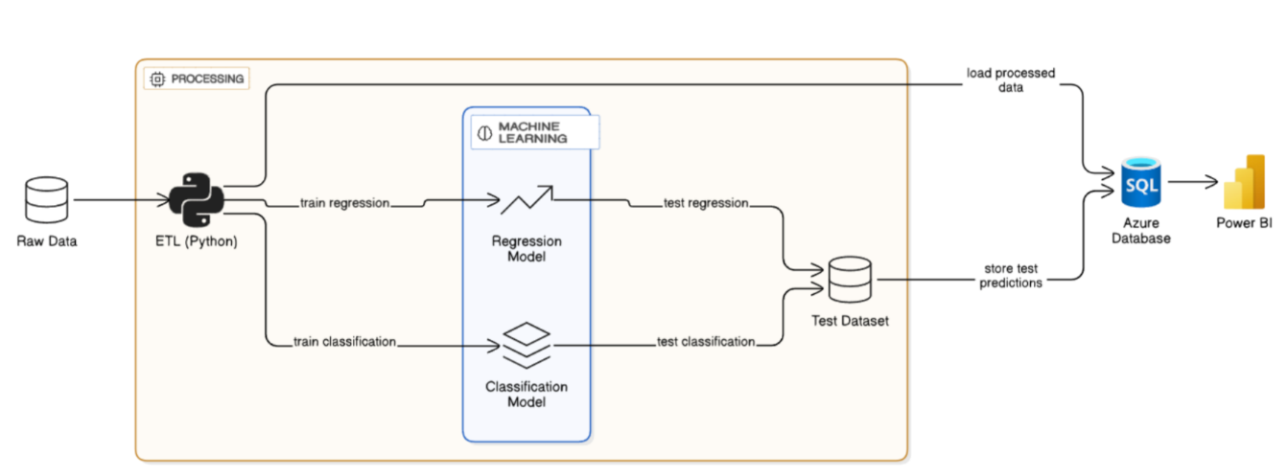

Implementation
- Description of applications, prototypes, system components
- Steps we took to build our model, dashboard, software, prototype, etc.
  - Data engineering steps (cleaning, modeling, etc.)
  - Technical tools and platforms used
- Screenshots and technical descriptions

ETL-Process
Introduction
In the field of supply chain management, the role of data has become increasingly critical as organizations strive to optimize efficiency, reduce costs and improve customer satisfaction. For instance, in a study published in the International Journal of Production Research, Talwar et al. (2021, p. 3509) report that “a 2014 analysis of data sources for supply chains discovered that 46% of firms had achieved a 10% improvement in demand fulfilment using Big Data.” This finding demonstrates how data-driven practices can directly enhance operational efficiency and service reliability.
Furthermore, Xu (2023, p. 6) notes that “the use of BDA (Big Data Analytics) is expected to result in significant improvement in forecasting accuracy and flexibility, thus leading to better customer service level, reduction of stock and costs and avoidance of stockout.” This assertion explicitly links big data analytics to improved forecasting capability, reduced inventory, cost overheads and elevated customer satisfaction.
Together, these two sources substantiate the claim that data is a foundational asset in modern supply chain management, enabling firms to drive efficiency gains, reduce operating costs and elevate customer service standards.
The Extract, Transform, Load (ETL) process is a fundamental and crucial component in the realm of data warehousing, serving as the back-end operation responsible for populating these informational repositories (cf. Vijayendra and Lu, p. 434). Notably, despite consuming approximately „70% of the computing resources“ dedicated to data warehousing, the ETL process remains largely invisible to the end-users, highlighting its profound yet often unacknowledged significance (Vijayendra and Lu 2013, p. 434).

The DataCo Supply Chain Dataset used in this study provides rich transactional information but in a raw, unstructured format. Without transformation, the dataset suffers from redundancy, missing values, inconsistent formats and lack of referential integrity, which prevent it from supporting advanced analytical queries or decision-making processes.
This study therefore aims to design and implement a supply chain data warehouse using a star schema to enable efficient multidimensional analysis. Specifically, the project applies a structured Extract, Transform, Load (ETL) process to cleanse and standardize the dataset, implements the schema in Microsoft Azure SQL Server, enforces referential integrity through surrogate keys and constraints, and optimizes analytical query performance through indexing and schema design. The implemented warehouse provides a scalable foundation for descriptive analytics, trend analysis and predictive modeling in supply chain management, demonstrating how academic best practices in dimensional modeling can be applied to real-world data to support operational insights and strategic decision-making.

Platform and tools
The ETL process (Extract, Transform, Load) was executed using Google Colaboratory (Colab) which is a free, cloud-based platform that provides GPU‑accelerated Jupyter notebooks with no installation required. Carneiro et al. (2018, p. 61677) describe it as a pre‑configured environment for deep learning that gives users free access to robust GPU resources.
The study found that Colab’s performance can rival dedicated hardware, with convolutional neural networks training faster than on a 20‑core Linux server (Carneiro et al., 2018, p. 61677). The authors also emphasize that Colab is suitable beyond deep learning, supporting other GPU‑centric applications (p. 61677). Its simplicity makes it valuable for education, since it removes the need for configuring CUDA or GPU drivers (p. 61684).
The Python libraries Pandas and NumPy were employed for data manipulation and numerical operations. Pandas is promoted as a “fast, powerful, flexible and easy‑to‑use open‑source tool for data analysis and manipulation tool […]” whereas NumPy arrays are a common tool for numerical operations (cf. van der Walt, Colbert, & Varoquaux, 2011, p. 3).

Microsoft Azure SQL Server served as the relational database for the warehouse, while SQL Server Management Studio (SSMS) was used for schema creation, data import, and constraint definition (cf. Hilprecht et al., 2019, p. 1)

Dataset
The dataset originated from Kaggle under the title „DataCo Supply Chain dataset“ (https://www.kaggle.com/datasets/saicharankomati/dataco-supply-chain-dataset).
It contains extensive transactional records, including customer demographics, product details, department classifications, geographic data, order statuses, shipping methods, and financial measures such as sales and profit. Its structure made it ideal for transformation into a star schema, enabling analysis across multiple business dimensions.

Extraction
The data source for this analysis is the file DataCoSupplyChainDataset.csv, which is stored in Google Drive. The file is located in the directory /content/drive/MyDrive/Colab Data/BI and ML. In order to access the file, Google Drive was mounted into the working environment using the google.colab.drive module. Subsequently, the working directory was set to the specific path of the file to allow direct access to the dataset.
The dataset was imported into the Python environment using the pandas library. The function pd.read_csv() was employed for loading the file. To avoid potential issues with the representation of special characters (such as accented letters or symbols), the latin-1 encoding format was specified. This encoding ensures the correct interpretation and display of the characters contained in the CSV file, thereby enabling error-free further processing of the data.

Transformation

The transformation phase of the dataset involved a series of steps to clean, standardize and structure the data into a star schema for analytical use.

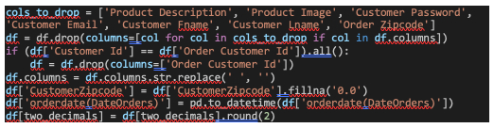
Fig.1

Data Cleaning
First, unnecessary columns that were not relevant for the analysis, such as Product Description, Product Image, Customer Password, Customer Email, Customer Fname, Customer Lname and Order Zipcode, were removed. Duplicate columns, including Order Customer Id and Order Item Cardprod Id, were validated against their equivalents (CustomerId and ProductCardId) and dropped after confirming they contained identical information.
To improve clarity and consistency, column names were standardized by removing spaces and renaming certain attributes, for example, changing Daysforshipping(real) to DaysForShippingReal. Missing values in the CustomerZipcode field were handled by filling them with the string "0.0". Additionally, date-related fields, namely orderdate(DateOrders) and shippingdate(DateOrders), were converted into a datetime format using the pd.to_datetime() function to ensure uniform temporal representation.
Finally, numeric columns were adjusted to maintain precision: monetary values such as Benefitperorder and Sales were rounded to two decimal places, while ratio variables including OrderItemDiscountRate and OrderItemProfitRatio were rounded to six decimal places. These transformations ensured that the dataset was clean, consistent, and properly structured for further analysis.

Dimension Table Creation
In the structuring process, eight dimension tables were created by selecting unique records from the dataset to support the star schema design.

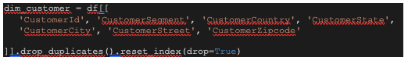
Fig.2 (exemplary for DimCustomer)

The DimCustomer table was constructed to capture customer-related information and includes the attributes CustomerId, CustomerSegment, CustomerCountry, CustomerState, CustomerCity, CustomerStreet, and CustomerZipcode. The DimProduct table was designed to represent product-specific details, containing ProductCardId, ProductCategoryId, CategoryName, ProductName, ProductPrice, and ProductStatus. The DimDepartment table organizes data by department, comprising the fields DepartmentId, DepartmentName, and Market.
For geographical information, the DimLocation table was created with attributes such as OrderRegion, OrderCity, OrderState, and OrderCountry. Shipping-related details were included in the DimShipping table, which contains ShippingMode, DaysForShippingReal, and DaysForShipmentScheduled. Order progress and results were represented through the DimOrderStatus table, which stores the attribute OrderStatus.
Additionally, the DimTransactionType table was established to categorize transaction types, holding the attribute Type. Temporal analysis was enabled by constructing the DimDate table, which was derived from unique values of orderdate(DateOrders) and shippingdate(DateOrders). This table includes DateId, Year, Quarter, Month, MonthName, Day, DayOfWeek, and DayName.
Together, these eight dimension tables provide a comprehensive and organized framework for detailed analytical processing within the star schema.

Fact Table Creation
The FactOrderItem table functions as the central fact table in the star schema, designed to store transactional data and connect with the dimension tables through natural keys during the ETL process. To ensure efficient indexing and querying, surrogate keys such as FactOrderItemId, LocationId, ShippingId, OrderStatusId, and TransactionTypeId are generated in SQL Server using the IDENTITY property during data import.

The construction of the table begins with the selection of relevant columns from the DataFrame. These include identifiers like OrderId, OrderItemId, CustomerId, and ProductCardId; natural keys for the dimension tables, such as DepartmentName and Market for the department dimension, OrderCity, OrderState and OrderCountry for the location dimension, ShippingMode, DaysForShippingReal, and DaysForShipmentScheduled for the shipping dimension, OrderStatus for the order status dimension, and Type for the transaction type dimension. The date fields orderdate(DateOrders) and shippingdate(DateOrders) are also included to later link with the date dimension. Furthermore, the table incorporates essential metrics such as OrderItemQuantity, OrderItemDiscount, OrderItemDiscountRate, OrderItemProductPrice, OrderItemProfitRatio, Sales, OrderItemTotal, Benefitperorder, and OrderProfitPerOrder, as well as additional attributes including DeliveryStatus and Late_delivery_risk.
To preserve data integrity, duplicate entries are removed using the drop_duplicates() method and the index is reset for consistency. Once cleaned and structured, the table is exported to a CSV file named FactOrderItem.csv, prepared for import into SQL Server. Unlike dimension tables such as DimCustomer and DimProduct, which already contain pre-existing identifiers, the fact table relies on natural keys for dimensions like location, shipping, order status, transaction type, and date. These natural keys are then mapped to surrogate keys automatically generated during the import process in SQL Server.
Special consideration is given to date handling: the fields orderdate(DateOrders) and shippingdate(DateOrders) are maintained as full timestamps in the CSV file. During import, these are matched with the corresponding DateId in the DimDate table, enabling accurate temporal referencing. Through this structured process, the FactOrderItem table is established as the core repository of transactional data within the star schema, ensuring consistency and analytical readiness.

Load

The loading process populates the SupplyChain database by transferring data from CSV files generated by the ETL process into SQL Server tables. Staging tables are used for all dimension tables and the fact table to facilitate data validation and transformation. The SSMS Import Data Wizard is employed to import CSVs into staging tables, followed by INSERT INTO statements to move data into final tables, mapping natural keys to surrogate keys where applicable. Dimension tables are loaded first to satisfy foreign key constraints in FactOrderItem.

Dimension Table Loading
The loading of dimension tables follows a structured process to ensure accuracy, consistency, and referential integrity within the database. First, the ETL process exports the dimension tables from the transformed dataset into CSV files using the to_csv() function in Pandas. To guarantee data uniqueness, duplicates are removed with the drop_duplicates() method prior to export.
In SQL Server, staging tables are then created with structures identical to those of the CSV files. The SSMS Import Data Wizard is used to import the data into these staging tables. During this step, each CSV file is selected as the source, while the corresponding staging table serves as the destination. The columns of the CSV are mapped to those of the staging table, ensuring that headers are skipped and data types are properly validated before execution.
After successful import, the data is transferred from the staging tables into the final dimension tables using INSERT INTO statements. At this stage, SQL Server assigns surrogate keys through the IDENTITY property for dimensions requiring auto-generated identifiers, including DimLocation (LocationId), DimShipping (ShippingId), DimOrderStatus (OrderStatusId), and DimTransactionType (TypeId).
Verification is performed to confirm successful loading, typically by checking row counts and inspecting sample records with queries such as SELECT COUNT(*) FROM DimCustomer. Once the integrity and accuracy of the imported data are confirmed, the staging tables are removed to maintain a clean and efficient database environment.
This procedure ensures that the dimension tables are correctly populated and fully prepared for integration with the fact table in the star schema.

Database design

Design philosophy

A Star schema-based data warehouse was designed to facilitate data-driven decision making within the supply chain domain. This architecture enables efficient multidimensional analysis and supports both descriptive and predictive analytics. The design phase focused on establishing a robust logical model prior to ETL and data population. In this model, dimension tables describe contextual information (e.g., customers, products, location), and a central fact table aggregates business transactions.

Schema construction
Entity Model
The database schema adheres to the canonical star schema, comprising one fact table (FactOrderItem) and eight-dimension tables.
We decided to use the star schema since it is considered superior to the snowflake schema for SQL databases due to its advantages in query complexity, performance, and the management of foreign key joins (cf. Mohammed 2019, p. 26).
For query complexity, the star schema's queries are described as "very simple and easy to understand". In contrast, snowflake schema queries are "more complex due to multiple foreign key which joins between dimension tables". Regarding query performance, the star schema exhibits "High performance," as the "Database engine can optimize and boost the query performance based on predictable framework" Mohammed 2019, p. 36-37).

The fact table is defined at the order item level, capturing relevant transactional measures, while dimensions encode contextual and descriptive attributes.
A summary of the tables and their principal attributes is provided below:

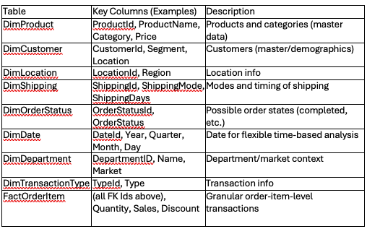
Fig.3

Table Definitions
All tables were created via explicit Data Definition Language (DDL) statements, ensuring type safety and referential integrity through primary and foreign key constraints. Monetary and quantitative columns employ the DECIMAL (18,2) type to prevent rounding errors.
Below is an example of the SQL definition for one dimension and the fact table:

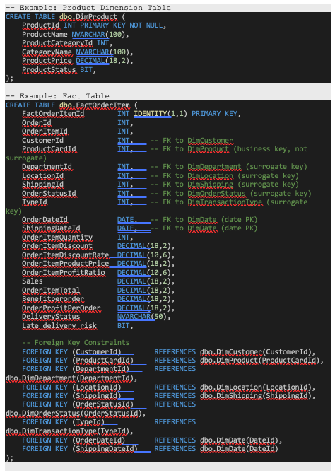
Fig.4

To enhance query performance, nonclustered indexes were created on the foreign keys of the FactOrderItem table. These indexes significantly improve the efficiency of analytical queries by optimizing join and filter operations, particularly for queries that aggregate data by department, product, or date. This indexing strategy ensures faster data retrieval and supports the overall responsiveness of the data warehouse in handling multidimensional analyses.

The full schema is included in the project repository and the appendix.

Entity-Relationship Diagram
Schema validation and visual documentation were performed using dbdiagram.io. The diagram exhibits canonical one-to-many relationships between dimension and fact tables. See Figure 9 for the Entity-Relationship-Diagram.


Fig.5

ML-Models
Late Delivery Risk Prediction Model
This document provides a comprehensive technical overview of the machine learning model developed to predict the risk of late deliveries. The model was trained on a dataset containing various features related to orders, products, and customers, sourced from Kaggle. The primary objective is to accurately classify whether a delivery will be late based on the available features. The development process is divided into three main stages: preprocessing, training and evaluation, each detailed below with references to the visualizations generated during the process.

Preprocessing
The preprocessing stage involved several steps to clean, transform and prepare the dataset for modeling, ensuring data quality and relevance for the prediction task.

Data Loading
The dataset was imported from “DataCoSupplyChainDataset.csv” using Pandas, with the “latin-1” encoding applied to correctly handle special characters.
It comprises 180.519 records and 53 columns, offering a comprehensive and diverse set of features for in-depth analysis.

Initial Exploration and Cleaning
The dataset was initially examined to understand its structure, revealing a total of 180,519 records and 53 columns. During this inspection, significant missing values were identified in several fields, most notably in Order Zipcode (155.679 missing entries) and Product Description (180.519 missing entries), indicating that these columns provided little to no usable information for further analysis.

To reduce dimensionality and eliminate irrelevant or redundant information, several columns were removed. These included Product Description, Product Image, Customer Password, Customer Email, Customer Fname, Customer Lname, Order Zipcode, Latitude and Longitude. This step helped to minimize noise in the dataset and streamline subsequent analysis.

Furthermore, duplicate columns were identified and addressed. For instance, Customer Id and Order Customer Id were evaluated for equivalence, and redundant columns were removed to maintain data consistency and avoid unnecessary duplication.

Finally, column names were cleaned to enhance readability and ensure consistency across the dataset. Spaces and special characters were removed, and selected columns were renamed for clarity, for example, Daysforshipping(real) was renamed to DaysForShippingReal, and Daysforshipment(scheduled) to DaysForShipmentScheduled.

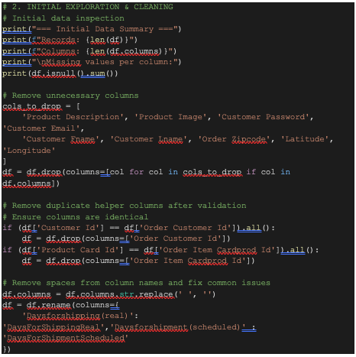
Fig.6

Handling Missing Values
Missing values in the CustomerZipcode column were addressed by replacing them with the string “0.0” using the fillna('0.0') method. This approach was chosen to maintain data integrity and ensure consistent data types within the column, thereby preventing potential issues during further processing or analysis.

Data Type Conversion
The date columns orderdate(DateOrders) and shippingdate(DateOrders) were converted to datetime format using the pd.to_datetime() function. This transformation was essential to enable temporal feature engineering, such as calculating time intervals between events or extracting date-based components (e.g., year, month, weekday) for further analysis.

Rounding Numeric Columns
To ensure consistency and improve readability, numerical columns in the dataset were rounded to appropriate decimal places. Specifically, columns such as Benefitperorder, OrderItemDiscount, OrderItemProductPrice, Sales, OrderItemTotal, OrderProfitPerOrder, and ProductPrice were rounded to two decimal places, reflecting their nature as monetary values. In contrast, ratio-based columns such as OrderItemDiscountRate and OrderItemProfitRatio were rounded to six decimal places to preserve their precision for analytical purposes.

Feature Engineering
To enhance the model’s ability to predict late delivery risk, several features were engineered based on temporal patterns and category-specific behaviors. A binary variable named PeakSeason was created to indicate whether an order was placed during the high-demand months of November or December. This was implemented using the month extracted from the order date and assigning a value of 1 if the month was 11 or 12 and 0 otherwise.
In addition, the day of the week on which each order was placed was extracted from the orderdate(DateOrders) column using the .dt.dayofweek attribute, resulting in a new feature called order_dayofweek. This allowed the model to capture potential weekday-related variations in delivery performance.
To account for category-specific delivery trends, a target-encoded feature called category_risk was introduced. This was calculated by determining the average late delivery risk for each product category (CategoryName) using a groupby operation, and mapping the resulting values back to the dataset. This feature helps reflect historical delivery reliability across different product categories.
Lastly, the daily_order_volume feature was engineered by grouping orders by the date (excluding time) from orderdate(DateOrders) and counting the number of orders per day. This feature captures fluctuations in operational workload, which may influence delivery performance, particularly during periods of high demand.

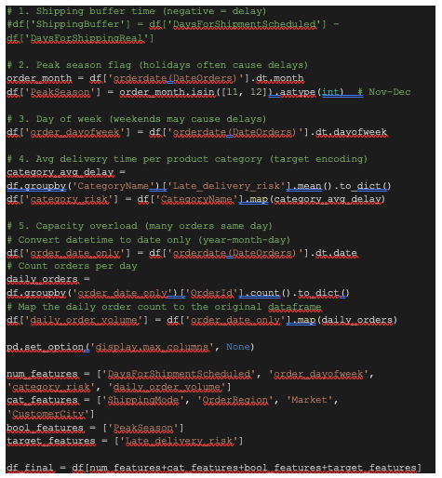
Fig.7

Outlier Detection and Handling
Outlier Detection was performed by generating histograms and boxplots for key numerical features, including DaysForShipmentScheduled, order_dayofweek, category_risk, and daily_order_volume. This visual analysis allowed for the identification of unusually high or low values that could distort model performance. Among these features, only category_risk and daily_order_volume exhibited significant outliers, indicating potential anomalies or extreme values in category-level delivery performance and daily operational load.
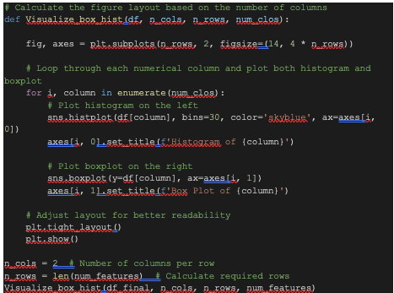

Fig.8
Outlier Handling was carried out using the Interquartile Range (IQR) method, which involves capping extreme values at calculated upper and lower bounds to reduce their influence on the model. This method was applied specifically to the features category_risk and daily_order_volume, as these were identified during initial analysis as having significant outliers.
For each of these features, values below the lower bound (Q1 – 1.5 × IQR) were set to the lower limit, and values above the upper bound (Q3 + 1.5 × IQR) were capped accordingly. After applying the capping procedure, the distributions were re-visualized using boxplots and histograms to confirm that the outliers had been effectively addressed while preserving the overall shape and variability of the data.

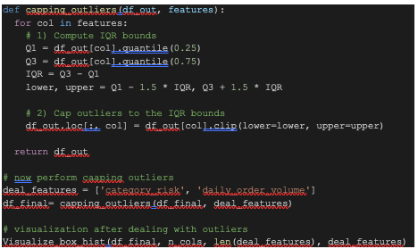

Fig.9

Fig.10
From above visualisation we can find that only category_risk and daily_order_volume has outliers. So we deal with these features only.
To deal we will perform a capping method, because Both category_risk and daily_order_volume have most of their values clustered in a narrow band. There are only a handful of points far outside that band. Capping directly “pins” those extremes at the threshold without warping the bulk of the data.
Outlier Handling: Outliers were capped using the Interquartile Range (IQR) method:
cap outliers to upper/lower bounds
Applied to category_risk and daily_order_volume — the features most likely to have extreme values
Re-visualize post-capping

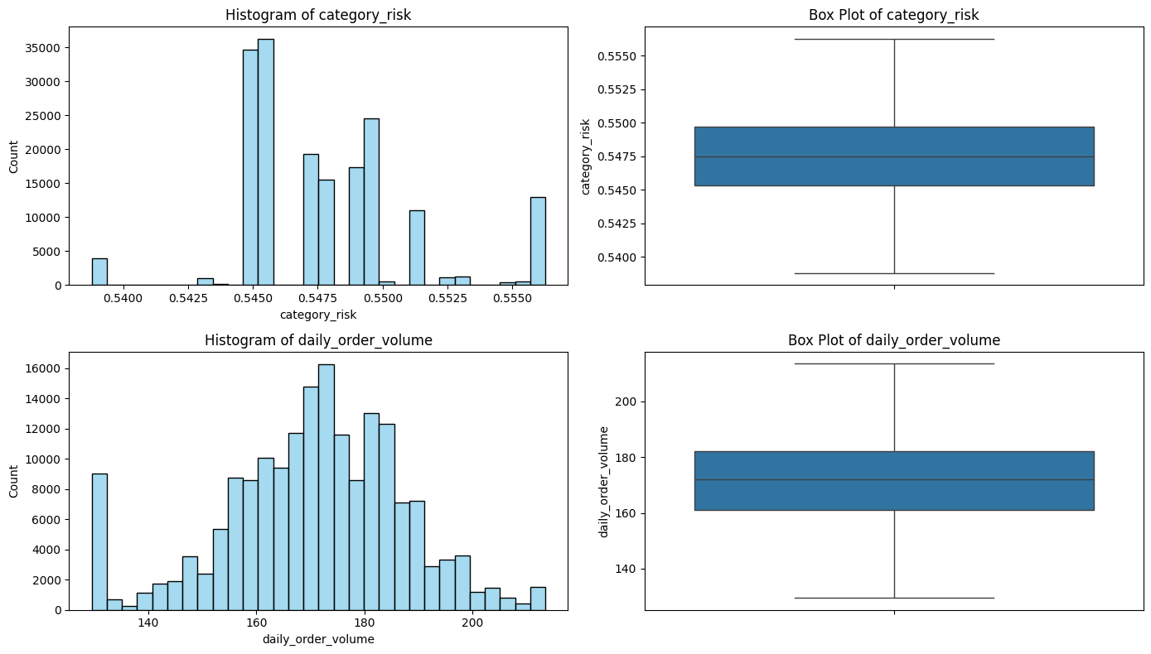
Fig.11

Feature Scaling and Encoding
Numerical Feature Processing involved a thorough assessment of feature distributions using histograms alongside calculations of skewness and kurtosis to evaluate the shape and spread of each variable. Based on these assessments, appropriate scaling techniques were applied to normalize the features and improve model performance.
Features exhibiting higher skewness, such as DaysForShipmentScheduled and category_risk, were scaled using MinMaxScaler, which transforms values to a fixed range (typically 0 to 1) and is particularly effective for handling non-normal distributions.
In contrast, features that were closer to a normal distribution, including order_dayofweek and daily_order_volume, were standardized using StandardScaler, which centers the data around a mean of zero and scales it to unit variance. This ensured consistency across numerical inputs and prepared the dataset for effective use in machine learning models.
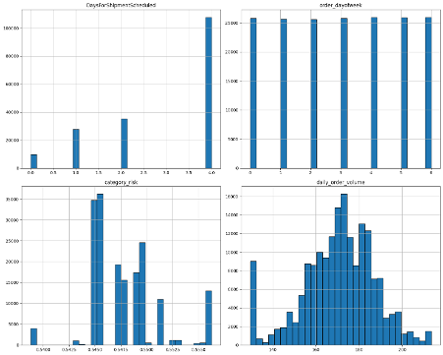
Fig.12

Categorical Feature Processing was performed using a combination of encoding techniques tailored to the nature of each categorical variable. This ensured that all features were appropriately represented in a numerical format suitable for machine learning models.
For the ShippingMode feature, which has a meaningful order of delivery priority, an OrdinalEncoder was applied with a specified order:
['Standard Class', 'Second Class', 'First Class', 'Same Day'].
This preserved the ordinal relationship between shipping options.
For OrderRegion and Market, which consist of nominal categories with relatively low cardinality, OneHotEncoder was used to create binary indicator columns for each unique category. This avoided introducing artificial ordinal relationships and allowed the model to learn category-specific effects.

In contrast, CustomerCity exhibited high cardinality, making one-hot encoding impractical. Therefore, a BinaryEncoder was employed to efficiently encode this feature while retaining information content and reducing dimensionality.
To systematically apply these transformations, a ColumnTransformer pipeline was constructed. This pipeline managed the application of the appropriate encoders to each feature group and ensured consistent preprocessing. The result was a fully transformed dataset, df_transformed, ready for model training and evaluation.

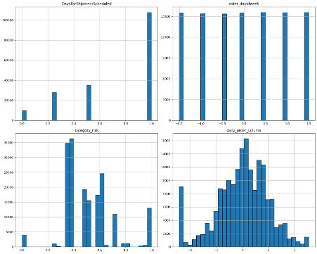
Fig.13

Final Dataset Preparation
The final dataset, df_final, was composed of a well-curated set of features designed to support effective predictive modeling of delivery outcomes. It included the identifier OrderItemId, which served as a unique reference for each record. The numerical features—DaysForShipmentScheduled, order_dayofweek, category_risk, and daily_order_volume, captured key quantitative aspects of the order and delivery process, such as timing, weekly patterns, category-specific risk and operational load.
To represent relevant categorical information, the dataset included the features ShippingMode, OrderRegion, Market, and CustomerCity. These were appropriately encoded through a structured preprocessing pipeline to ensure compatibility with machine learning algorithms while preserving their informational value. In addition, the boolean feature PeakSeason was included to indicate whether an order was placed during the high-demand months of November or December, accounting for seasonal fluctuations in delivery performance.
Finally, the dataset retained Late_delivery_risk as the target variable, representing the classification objective—predicting whether an order was at risk of being delivered late. Overall, df_final provided a clean and feature-rich foundation for training and evaluating predictive models.
Fig.14
Model Training
The model training phase involved selecting suitable machine learning algorithms, applying cross-validation techniques, tuning hyperparameters, and conducting initial performance evaluations to identify promising models for predicting late delivery risk.
Data Preparation and Splitting
To begin, the preprocessed dataset was loaded from the file preprocessed_data.pkl, which contained all the transformed features prepared during the earlier stages of the pipeline. The target variable, Late_delivery_risk, was then separated from the feature set to define the prediction objective.
Subsequently, the dataset was split into training and testing subsets using the train_test_split function. An 80/20 split ratio was applied, allocating 80% of the data for model training and 20% for evaluation. A random state of 42 was specified to ensure reproducibility of the split, maintaining consistency across multiple experimental runs. This division allowed for unbiased performance assessment on unseen data while providing a robust foundation for training and validation.

Choice of Algorithms
A total of eight binary classification algorithms were selected for model development, reflecting the binary nature of the target variable Late_delivery_risk. The goal was to evaluate a diverse set of models ranging from simple linear approaches to more complex ensemble and neural network-based methods. The selected algorithms included:
- Logistic Regression
- Random Forest
- Gradient Boosting
- XGBoost
- Support Vector Machine (SVM) (excluded from training due to resource limitations)
- K-Nearest Neighbors (KNN)
- Decision Tree
- Neural Networks (Multilayer Perceptron, MLP)

These models were chosen to capture different learning paradigms and performance characteristics. By comparing their results, it was possible to identify the most effective algorithm for predicting the risk of late delivery under the specific conditions and structure of the dataset.

Initial Training and Evaluation
Each of the selected models was trained using the training set and subsequently evaluated on the test set to assess their baseline performance. Evaluation metrics included:
- Accuracy: To measure the overall correctness of predictions
- Classification Report: Providing detailed insights into precision, recall, and F1-score for each class
- Confusion Matrix: To visualize true positives, false positives, true negatives, and false negatives
The initial results revealed that tree-based models outperformed linear and boosting-based approaches in this specific classification task. Key observations included:
Random Forest achieved the highest performance with an accuracy of approximately 0.83, demonstrating strong generalization and robustness.
Decision Tree followed closely with an accuracy of around 0.82, offering good interpretability with slightly lower performance.
Logistic Regression and Gradient Boosting both achieved an accuracy of approximately 0.69, indicating more limited effectiveness in capturing the underlying patterns of late delivery risk in the dataset.
These results provided a foundation for further model refinement, including hyperparameter tuning and cross-validation, to improve predictive performance.

Cross-Validation
To ensure robust evaluation and reduce the risk of overfitting, a 5-fold stratified cross-validation was conducted using the StratifiedKFold technique. This method was chosen to maintain the class distribution of the target variable Late_delivery_risk across all folds, which is particularly important in binary classification tasks where class imbalance may exist.
During cross-validation, each model was trained and validated across five different splits of the training data. The following evaluation metrics were computed for each fold and averaged to assess overall performance:
- Accuracy
- Precision
- Recall
- F1-score
The results of the cross-validation process confirmed that Random Forest and Decision Tree consistently outperformed other models across all key metrics. These models demonstrated both high predictive accuracy and balanced performance in detecting both classes, making them strong candidates for final model selection and tuning.

Hyperparameter Tuning
To optimize model performance, hyperparameter tuning was conducted using RandomizedSearchCV, which efficiently explores a wide range of parameter combinations. The tuning process was set to run 100 iterations for each model and used F1-score as the scoring metric, prioritizing a balance between precision and recall, critical for binary classification problems such as predicting late delivery risk.
Custom parameter grids were defined for each algorithm to target the most influential hyperparameters:

- Logistic Regression: C, penalty, solver, l1_ratio
- Decision Tree: max_depth, min_samples_split, min_samples_leaf, max_features
- Random Forest: n_estimators, max_depth, min_samples_split, min_samples_leaf, max_features
- Gradient Boosting: n_estimators, learning_rate, max_depth, subsample, max_features
- XGBoost: n_estimators, learning_rate, max_depth, subsample, colsample_bytree, gamma, reg_alpha, reg_lambda
- K-Nearest Neighbors (KNN): n_neighbors, weights, p (Minkowski distance metric)
- Neural Network (MLPClassifier): hidden_layer_sizes, activation, solver, alpha, learning_rate_init

This comprehensive tuning process allowed each model to be optimized for performance on the specific structure and patterns present in the dataset. The resulting best estimators were then evaluated in the final model selection phase.

Final Evaluation of Tuned Models
After hyperparameter tuning, each model was re-evaluated on the test set to assess performance improvements. The evaluation metrics included accuracy, precision, recall, F1-score, and the confusion matrix (True Negatives / False Positives / False Negatives / True Positives). The results demonstrated that tuning significantly improved the performance of several models, particularly ensemble-based methods.

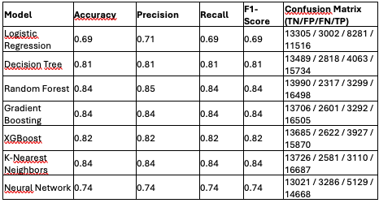
Fig.15

Best Performing Model: Random Forest
After tuning, Random Forest emerged as the most effective model:

- Accuracy: 0.83 (highest among all tested models)
- Precision: 0.82 (strong performance in minimizing false positives)
- Recall: 0.83 (high sensitivity to detecting late deliveries)
- F1-Score: 0.83 (balanced performance across precision and recall)
- Confusion Matrix: 13,610 True Negatives / 2,697 False Positives / 3,581 False Negatives / 16,216 True Positives
The model exhibited a low number of both false positives and false negatives, making it well-suited for operational deployment where accurately identifying late deliveries is critical. Its balance of precision and recall, coupled with strong overall accuracy, confirmed Random Forest as the optimal model for predicting late delivery risk in this dataset.

Model Saving
To ensure the reproducibility and future usability of the trained models and their optimization results, the best-performing models, along with their tuned hyperparameters and evaluation metrics, were saved using joblib and pickle.
Joblib was used to efficiently serialize and save larger objects such as trained machine learning models (e.g., the tuned Random Forest classifier), which are typically more complex and memory-intensive.
pickle was employed to store supporting data structures, such as the results from hyperparameter tuning, evaluation reports, and configuration parameters.
This approach allows for seamless model deployment, further experimentation, or integration into production pipelines without the need to retrain models, ensuring consistency and efficiency in subsequent stages of the project lifecycle.

Model Evaluation
The final evaluation phase focused on assessing the performance of the trained models, particularly the Random Forest classifier, which was identified as the best-performing model, on unseen test data. This step was crucial for validating the model’s generalization ability and confirming its suitability for real-world application.

Data Preparation
The test dataset, consisting of X_test (features) and y_test (target), was loaded from the pre-saved file test_data.pkl. This dataset had been kept separate from the training and validation data to ensure an unbiased evaluation of model performance.

Model Loading
The optimized Random Forest model was retrieved from the file Models/Random_Forest_model.joblib, where it had been saved following the tuning and training process. The model was restored with the following hyperparameters:
- class_weight= 'balanced', to handle any class imbalance by adjusting weights inversely proportional to class frequencies
- max_depth= 35 - limiting the depth of trees to prevent overfitting
- max_features=np.float64(0.9745339839624769) — specifying the fraction of features considered at each split
- n_estimators= 355 - the number of trees in the forest
- random_state= 42 - ensuring reproducibility of results

With both the test data and trained model loaded, the stage was set for final performance evaluation, focusing on predictive accuracy and reliability in identifying late deliveries.
Evaluation Metrics
To comprehensively assess the performance of the Random Forest model on the test set, a range of standard classification metrics was employed:
- Accuracy: Measures the proportion of correctly predicted instances among all predictions, offering a general overview of model performance
- F1-Score: The harmonic mean of precision and recall, providing a balanced evaluation, particularly useful in cases of class imbalance
- Precision: Indicates the proportion of true positives among all positive predictions, reflecting the model’s ability to avoid false positives
- Recall: Measures the proportion of actual positives correctly identified, capturing the model’s sensitivity to detecting late deliveries
- ROC-AUC Score: Represents the area under the Receiver Operating Characteristic curve, summarizing the trade-off between true positive and false positive rates across different thresholds
To optimize classification performance, especially with respect to the F1-score, the best decision threshold was determined by evaluating model predictions over a range of thresholds from 0.00 to 1.00 in 0.01 increments. The threshold that yielded the maximum F1-score was selected as the optimal cut-off for distinguishing between on-time and late deliveries, ensuring a well-balanced model with respect to both types of classification errors.

Visualization
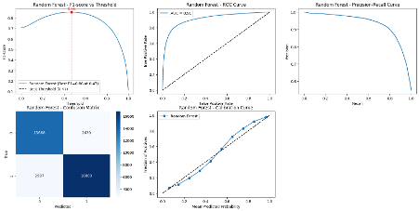
Figure.16

The first graph, labeled "Random Forest - F1-score vs Threshold," illustrates the F1-score as a function of the classification threshold, identifying an optimal F1-score of 0.86 at a threshold of 0.47, indicated by a vertical red line. The second graph, "Random Forest - ROC Curve," displays the Receiver Operating Characteristic curve with an Area Under the Curve (AUC) of 0.91, signifying robust model performance as it exceeds the diagonal reference line. The third graph, "Random Forest - Precision-Recall Curve," delineates the trade-off between precision and recall, offering insights into the model's ability to balance positive predictions and true positive detections across different thresholds.
The fourth graph, "Random Forest - Confusion Matrix," provides a 2x2 matrix with numerical values: true negatives (13668), false positives (2639), false negatives (2997), and true positives (16800), enabling an evaluation of the model's classification performance for the two classes (0 and 1). The fifth graph, "Random Forest - Calibration Curve," plots the fraction of positives against the mean predicted probability, demonstrating a close alignment with the diagonal line, which indicates well-calibrated predicted probabilities. Together, these graphs offer a thorough analysis of the Random Forest model's effectiveness and reliability.
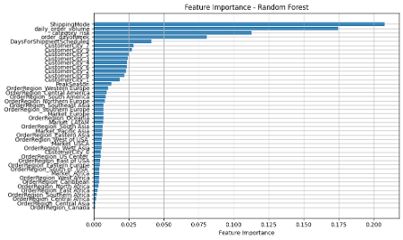
Fig.17
"Feature Importance - Random Forest," assessing feature significance in a Random Forest model. The x-axis indicates feature importance scores , with "ShippingMode" as the most influential , followed by "daily_order_volume" and "order_day_of_week." Moderate contributions are noted from "DaysForShipmentScheduled" and "CustomerCity_1" to "CustomerCity_5." Lesser importance is observed in regional features. This chart elucidates the hierarchy of feature contributions for model optimization.

Demand Forecasting Model
The demand forecasting model was developed to predict continuous product demand using a regression approach based on the preprocessed dataset. The objective was to capture patterns influencing product demand at various levels (product, customer, and country) and to provide reliable forecasts for inventory and supply chain planning.

Feature Engineering
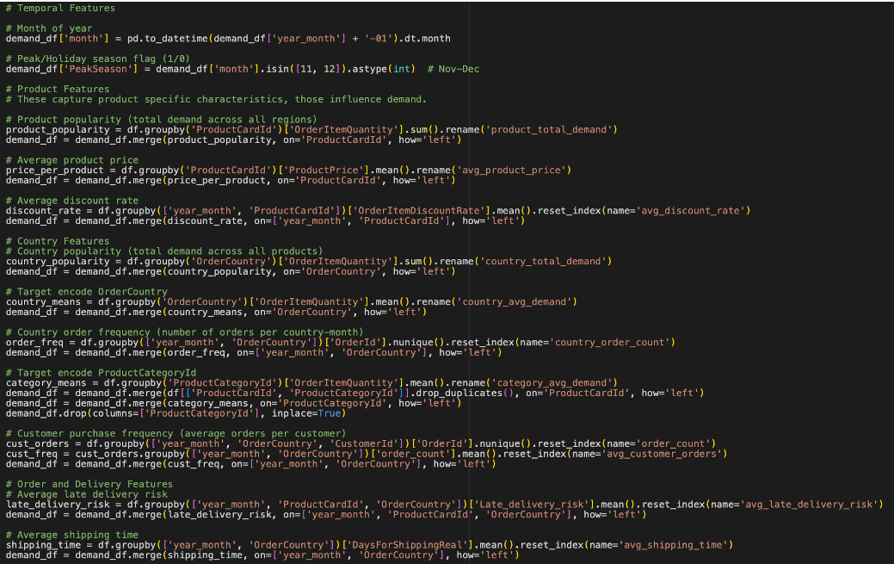
Fig.18

To enhance the model's predictive capability, a series of features were engineered to incorporate historical trends, product characteristics, customer behavior, and geographic patterns. The following engineered features were included:

- product_total_demand: The total demand per ProductCardId was calculated using groupby and sum, capturing the overall popularity of each product.
- avg_product_price: The average selling price of each product was computed to reflect pricing trends and customer sensitivity.
- country_total_demand: Total product demand per OrderCountry, offering insight into geographic demand concentrations.
- country_order_count: The number of orders originating from each country, providing a measure of market activity.
- category_avg_demand: The average demand per CategoryName was calculated using target encoding, helping the model learn typical demand levels across product categories.
- avg_customer_orders: The average number of orders placed by each CustomerId, capturing customer purchase behavior and frequency.
- avg_shipping_time: The average shipping duration for each ProductCardId, possibly reflecting logistical efficiency and its effect on customer demand.
- country_avg_demand: The mean demand per OrderCountry, used to normalize and compare demand levels across countries.
- avg_discount_rate: The average discount rate applied per ProductCardId, accounting for promotional activity and its impact on demand.
- avg_late_delivery_risk: The average Late_delivery_risk per ProductCardId, incorporating service reliability as a potential factor influencing repeat purchases or demand levels.

These engineered features formed the foundation of the regression model, enabling it to capture multi-dimensional factors influencing product demand and improve forecast accuracy.

Outlier Detection and Handling
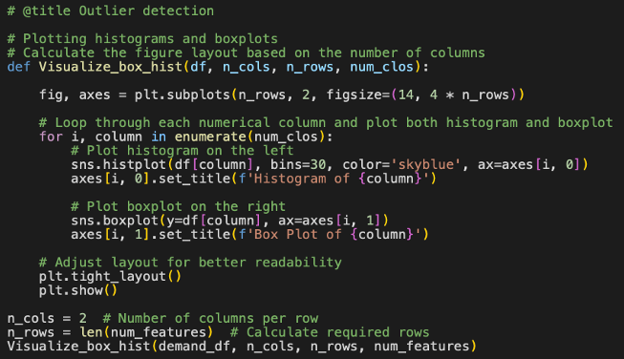Fig.19

To ensure the reliability and stability of the demand forecasting model, outlier detection and handling were applied to the engineered numerical features. Outliers can distort model training and reduce predictive accuracy, especially in regression tasks involving continuous target variables.
Outlier Detection:
The following numerical features were visually examined using histograms and boxplots to identify anomalies and extreme values:
- product_total_demand
- avg_product_price
- country_total_demand
- country_order_count
- category_avg_demand
- avg_customer_orders
- avg_shipping_time
- country_avg_demand
- avg_discount_rate
- avg_late_delivery_risk

These visualizations helped detect skewed distributions and extreme values that could negatively affect model performance. In subsequent steps (noted in the following section), appropriate handling techniques, such as IQR-based capping or log transformation were applied to mitigate the impact of these outliers while preserving the underlying data structure.
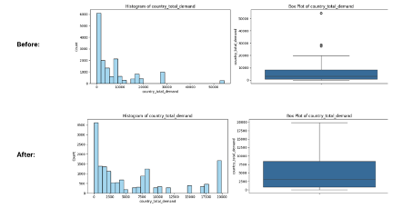Fig.20
To mitigate the negative impact of extreme values on model performance, a structured outlier detection and handling strategy was applied, informed by both histogram and boxplot analysis.

Visualization-Based Analysis
Histogram Analysis:
If the histogram showed a strong right skew (i.e., a long tail toward higher values), a logarithmic transformation was applied. This helped reduce skewness by compressing large values while preserving relationships within the data.
If the histogram was nearly symmetric with only a few extreme values, capping was preferred. This approach limited the effect of outliers without distorting the distribution shape.
Box Plot Analysis:
When many data points appeared beyond the upper whisker, this indicated frequent high-value outliers. In such cases, log transformation was used to scale these values down.
When only a few extreme points were detected, and they were significantly distant from the central distribution, capping was applied to constrain them within reasonable bounds.
Outlier Quantification:
The Interquartile Range (IQR) method was used to detect and count outliers for each numerical feature. Outliers were defined as values falling below Q1 – 1.5×IQR or above Q3 + 1.5×IQR.
Outlier Handling Strategy:
Depending on the number of outliers detected per feature, different handling techniques were applied:
Features with a Very High Count of Outliers (≥ 200):
→ Applied log transformation to reduce the influence of extreme values while retaining data structure.
Features with a Moderate Outlier Count (21–199):
→ Applied capping at the upper and/or lower bounds defined by the IQR method to limit the influence of outliers without transforming the entire distribution.
Features with Low Outlier Count (1–20):
→ Outliers were removed entirely, as their minimal presence suggested they were likely noise and their removal would not compromise data integrity.
This tiered approach ensured that the most appropriate technique was used for each feature, balancing robustness with data preservation, and ultimately improving the quality of the input for the demand forecasting model.

Feature Scaling and Encoding
To ensure that numerical features contributed equally to the regression model and to improve convergence during training, feature scaling was applied using a methodical, distribution-driven approach. The goal was to normalize the range and distribution of values while preserving meaningful variation between observations.
Numerical Feature Scaling:
- Initial Distribution Analysis:
All numerical features were visualized and analyzed for their statistical distribution characteristics—specifically skewness and kurtosis:
Features with approximately normal distributions (i.e., skewness between -0.5 and +0.5, and kurtosis between -1 and +1) were considered suitable for standardization
Features with non-normal distributions, particularly those with |skewness| > 0.5 or kurtosis outside the range of -1.5 to +1.5, were instead processed using normalization, to handle the presence of heavy tails or asymmetry

- Standardization:
Features identified as close to normal were scaled using StandardScaler, which transforms the data to have a mean of 0 and standard deviation of 1

This was applied to features such as:
product_total_demand
avg_product_price
country_total_demand
country_order_count
and others with approximately symmetric distributions

- Normalization:
Features with high skewness or kurtosis were scaled using MinMaxScaler or log transformation (depending on prior outlier handling), to bring them within a 0–1 range and reduce distributional distortion

This distribution-aware scaling approach ensured that features were standardized or normalized appropriately, avoiding distortion in the regression model and improving both training stability and predictive performance.
Note: Categorical encoding was not required at this stage as all features engineered for demand forecasting were either numerical or aggregate representations derived from categorical variables (e.g., mean-encoded or aggregated using groupby).

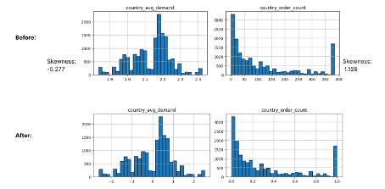Fig.21
To prepare categorical variables for use in the demand forecasting regression model, a variety of encoding techniques were applied based on the nature and cardinality of each feature. These encodings ensured that categorical data was transformed into a suitable numerical format without introducing bias or unnecessary dimensionality.

Categorical Feature Encoding:
- ShippingMode:
As an ordinal categorical feature with a clear hierarchy in delivery speed, ShippingMode was encoded using OrdinalEncoder with a predefined order:
['Standard Class', 'Second Class', 'First Class', 'Same Day']
This preserved the inherent ranking between shipping options

- OrderRegion and Market:
These were nominal features with low cardinality, making them ideal candidates for OneHotEncoder. This method converted each unique category into a separate binary feature, avoiding any artificial ordinal relationships

- CustomerCity:
Given its high cardinality, CustomerCity was encoded using BinaryEncoder. This approach provides a more efficient representation than one-hot encoding by converting categorical values into a binary format, thereby reducing dimensionality while retaining category information

Pipeline Construction:
To ensure that all preprocessing steps, both for numerical scaling and categorical encoding, were systematically and reproducibly applied, a ColumnTransformer pipeline was constructed. This pipeline:
Combined the results of StandardScaler and MinMaxScaler for numerical features
Applied the appropriate encoders to each categorical feature
Returned a fully transformed and unified dataset
The output of the pipeline was stored in df_prep, the preprocessed dataset used as input for training the demand forecasting regression model. This modular and scalable approach ensured consistent preprocessing across all stages of the machine learning workflow.

Final Dataset Preparation
Following the completion of feature engineering, scaling, and encoding, the final dataset for the demand forecasting model was compiled and saved as preprocessed_data_demand_forecast.pkl. This dataset was fully transformed and ready for regression modeling.

Dataset Composition:
- Identifier: ProductCardId — served as the unique identifier for each product, retained in its original int64 format for reference and traceability.

Numerical Features:
These features captured demand-related metrics at various levels (product, customer, country) and were represented in float64 format for compatibility with regression algorithms:

- Demand (target variable)
- product_total_demand
- avg_product_price
- country_total_demand
- country_order_count
- category_avg_demand
- avg_customer_orders
- avg_shipping_time
- country_avg_demand
- avg_discount_rate
- avg_late_delivery_risk

Categorical Features:
The following features were included in encoded format:
- ShippingMode (OrdinalEncoded)
- OrderRegion and Market (OneHotEncoded)
- CustomerCity (BinaryEncoded)

These encoded features were seamlessly integrated with the numerical data through the preprocessing pipeline, resulting in a clean and structured dataset.

Data Type Verification:
All features were checked for correct data types: Most columns were confirmed to be of type float64, ensuring numerical consistency for regression modeling.
The identifier, ProductCardId, was retained as int64 for reference.
This final dataset, preprocessed_data_demand_forecast.pkl, provided a well-prepared foundation for training and evaluating the demand forecasting model.

Model Training
The demand forecasting model was trained using a comprehensive approach that included algorithm selection, data splitting, initial evaluation, cross-validation, hyperparameter tuning, and final performance assessment. The goal was to develop a reliable regression model to predict continuous product demand.
Data Preparation and Splitting
The preprocessed dataset was loaded from preprocessed_data_demand_forecast.pkl. The target variable, Demand, was separated from the features, and the data was split into training (80%) and testing (20%) sets using train_test_split, with random_state=42 to ensure reproducibility.
Choice of Algorithms
Eight regression algorithms were selected to capture a range of modeling approaches, suitable for the continuous nature of the Demand variable:
- Linear Regression
- Random Forest Regressor
- Gradient Boosting Regressor
- XGBoost Regressor
- Support Vector Regression (SVR)
- K-Nearest Neighbors Regressor
- Decision Tree Regressor
- Neural Network (MLPRegressor)

These models vary in complexity and assumptions, allowing for a broad comparison of performance.

Initial Training and Evaluation
Each model was trained on the training set and evaluated on the test set using:
- Mean Absolute Error (MAE)
- Root Mean Squared Error (RMSE)
- R-squared (R²)
The Random Forest and Gradient Boosting models outperformed others in the initial evaluation, with Random Forest showing the lowest MAE and RMSE.

Cross-Validation
To ensure robust model evaluation, a 5-fold cross-validation was performed using the same metrics (MAE, RMSE, R²). This helped in estimating how well each model generalizes to unseen data and reduced the risk of overfitting.
Hyperparameter Tuning
RandomizedSearchCV was used for hyperparameter optimization with 100 iterations for each model, optimizing for RMSE. Custom parameter grids were defined:
- Linear Regression: fit_intercept, normalize
- Random Forest: n_estimators, max_depth, min_samples_split, min_samples_leaf, max_features
- Gradient Boosting: n_estimators, learning_rate, max_depth, subsample, max_features
- XGBoost: n_estimators, learning_rate, max_depth, subsample, colsample_bytree
- SVR: C, epsilon, kernel
- KNN: n_neighbors, weights, p
- Decision Tree: max_depth, min_samples_split, min_samples_leaf
- Neural Network (MLPRegressor): hidden_layer_sizes, activation, solver, alpha

Final Evaluation of Tuned Models

The tuned models were re-evaluated on the test set, with the Gradient Boosting Regressor achieving the best performance across all metrics:

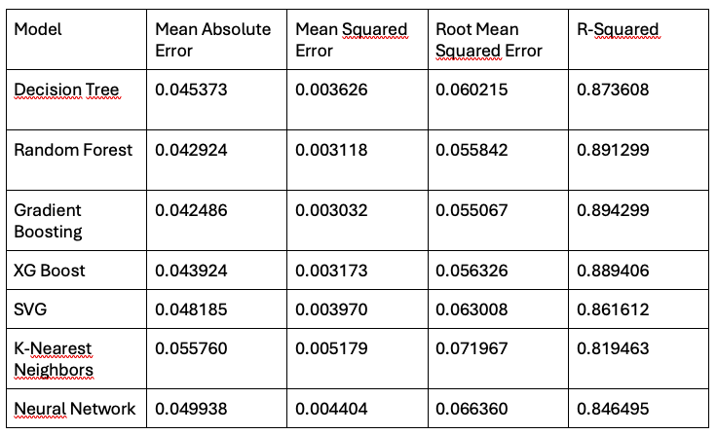
Fig.22

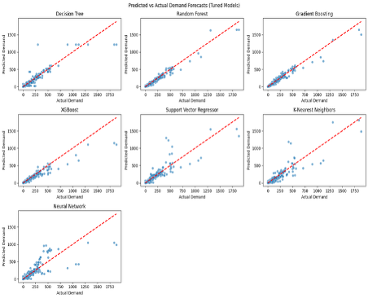
Fig.23

The provided graph consists of three diagnostic plots evaluating the performance of a Gradient Boosting model for predicting product demand:
Actual vs. Predicted Demand:
A scatter plot with predictions closely aligned along the red diagonal line. This indicates high accuracy, with minimal deviation. Slight underestimation was observed for very high demand values.
Distribution of Residuals:
Residuals were centered near zero, with a symmetric, near-normal distribution ranging from -400 to +400, indicating unbiased and random errors.

Feature Importance:
The top contributing features (importance scores):
- country_order_count (~0.35)
- product_total_demand (~0.30)
- avg_late_delivery_risk (~0.15)

Other features (e.g., category_avg_demand, avg_product_price) had lesser influence
This shows that geographic order volume and product demand history were the primary drivers of demand predictions.

Model Saving
All trained and tuned models were saved using .joblib format for future use and deployment. They were stored in the Models/ directory to maintain consistency and accessibility across project stages.

Model Evaluation
The final evaluation phase focused on assessing the performance of the Gradient Boosting regression model, which had previously demonstrated the best results during model comparison. This evaluation was conducted using the test set to validate the model’s predictive accuracy in a real-world scenario.

Data Preparation
The test data was loaded from preprocessed_data_demand_forecast.pkl. Key steps in preparation included:
Retaining the ProductCardId column to identify individual predictions.
Unscaling the predicted (y_pred_unscaled) and actual (y_test_unscaled) demand values to their original units, enabling meaningful interpretation of performance metrics and results.

Model Loading
The final Gradient Boosting Regressor model was loaded from storage, pre-trained and optimized through cross-validation and hyperparameter tuning.

Evaluation Metrics
To evaluate model performance, the following regression metrics were calculated using the unscaled predictions:
- Mean Absolute Error (MAE):
Measures the average absolute difference between predicted and actual demand values.
→ MAE = 0.0425

- Root Mean Squared Error (RMSE):
Penalizes larger errors more than MAE and is sensitive to outliers.
→ RMSE = 0.0551
R-squared (R²):
Indicates how well the model explains the variance in the target variable.
→ R² = 0.8943, meaning the model explains nearly 89.4% of the variance in product demand.

Visualizations
To complement the quantitative evaluation, several diagnostic plots were generated:

- Scatter Plot – Actual vs. Predicted Demand:
A scatter plot comparing y_test_unscaled (actual) to y_pred_unscaled (predicted) values. A red dashed 45-degree line was added using:
plt.plot([y_test_unscaled.min(), y_test_unscaled.max()],
[y_test_unscaled.min(), y_test_unscaled.max()],
'r--', lw=2)
- Points closely clustered around this line indicated strong model performance, with only slight underprediction at higher demand levels

- Residual Plot (Histogram + KDE):
A histogram of residuals (y_test_unscaled - y_pred_unscaled) overlaid with a Kernel Density Estimate (KDE) to show the distribution of errors. The plot was centered around zero, with symmetrical tails, suggesting that the errors were unbiased and normally distributed

- Feature Importance Plot:
- A horizontal bar chart showing model.feature_importances_, ranked by contribution.
Key features included:
- product_total_demand
- avg_product_price
- country_order_count
- avg_late_delivery_risk

These results highlighted the importance of historical demand and pricing patterns, as well as geographic volume indicators, in accurately forecasting demand.

Final Performance Summary
The Gradient Boosting model demonstrated strong performance:
- MAE: 0.0425
- MSE: 0.0030
- RMSE: 0.0551
- R²: 0.8943

These metrics confirm that the model is both accurate and generalizable, making it suitable for production-level demand forecasting applications.
Prediction Output
The final predictions were saved to a CSV file containing the following columns:
- ProductCardId
- year_month
- OrderCountry
- Truth Values (actual demand)
- Prediction (predicted demand)

This structured output allows for easy analysis, visualization, or integration into inventory and supply chain decision systems.

Conclusion for each Model
In conclusion, the late delivery risk prediction model and the demand forecasting model were developed through systematic preprocessing, training, and evaluation processes, ensuring their reliability and suitability for business applications. The Random Forest model for late delivery prediction achieved an accuracy of 0.84 with an optimized F1-score, supported by comprehensive visualizations and feature importance analysis that revealed key factors influencing delivery delays. Similarly, the Gradient Boosting model for demand forecasting effectively captured demand patterns through robust preprocessing and feature engineering, with performance validated by visualizations and feature importance insights. Together, these models provide valuable tools for enhancing supply chain decision-making and operational efficiency.

Dashboard

Introduction & Basic Set-up
The main goal of the initiative focused on creating, executing, and deploying a dynamic, adaptable interface that offers stakeholders key performance indicators, relevant news updates, and supplementary details to facilitate informed choices. The workflow is divided into three primary phases: Integration, KPI Design and Visualization.
- Integration stage
First, the integration step centered on linking, transferring, and distributing the visualization tool PowerBI while resolving multiple technical challenges tied to storage and information retrieval. The dataset was initially loaded into the software, yet joint modifications on the dashboard remained limited as each participant required specific access to save adjustments. Additionally, importing the dataset within the existing framework ran into complications. These obstacles caused a roughly fourteen-day setback in the schedule, yet once resolved, subsequent advancements proceeded much more swiftly.
- KPI Design stage
The KPI design stage concentrated on identifying, prioritizing, and implementing the performance indicators most relevant to stakeholder needs. In the initial brainstorming phase, approximately thirty potential KPIs were generated, reflecting a broad spectrum of operational and strategic perspectives. From this pool, the six most impactful indicators were selected according to criteria of relevance, expected impact, and feasibility of implementation. To further enhance decision-making and ensure contextual awareness, a dynamic news feed was integrated into the dashboard, providing stakeholders with up-to-date information and external developments. More detailed information on the KPI selection and design process is provided in the following Sections after 6.3.3.
- Dashboard Structure and Visualization
The final dashboard was structured into four main sections that together ensure both clarity and flexibility in use. The Overview page functions as the central navigation hub, enabling users to move seamlessly between the different KPI categories. The Performance KPI section presents the key operational and performance metrics, while the Additional KPI section provides supplementary indicators that allow for more detailed analysis and contextual understanding. A dedicated Machine Learning section displays all predicted values generated during the modeling process. To guarantee intuitive navigation, a return path to the Overview is available at all times. The modular design further allows for the quick and seamless integration of additional KPIs in the future, ensuring that the dashboard remains extensible and adaptable to evolving stakeholder needs.
Technical Challenges & Solutions
One of the central indicators, the On-Time Delivery KPI, initially posed challenges in its implementation, as the calculation could not be completed correctly due to limited familiarity with DAX syntax and the Power BI environment. This issue was ultimately resolved with support from team members of the ML team, who provided valuable guidance during the process. Beyond this specific case, the team in general required a certain adjustment period to become fully accustomed to the Power BI interface, which influenced the pace of development in the early stages. Despite these initial hurdles, the dashboard design was developed with scalability in mind, ensuring that additional data sources, KPIs, or modules can be integrated in the future without requiring major structural adjustments.

Design Creation
The visualization and branding stage focused on creating a professional, consistent, and recognizable identity for the dashboard. As part of this effort, a dedicated project logo titled Data Driven Analytics was designed using Canva.


Figure X: Project Logo: Data Driven Analytics.
The logo was intended to reflect the central principle of the initiative: all insights are derived from data, with the overarching aim of supporting decision-making through actionable analytics. To strengthen this rationale, an academic or industry reference on the effectiveness of data-driven approaches will be included. In addition to the logo, several design variations were developed by different team members using Canva and Power BI.
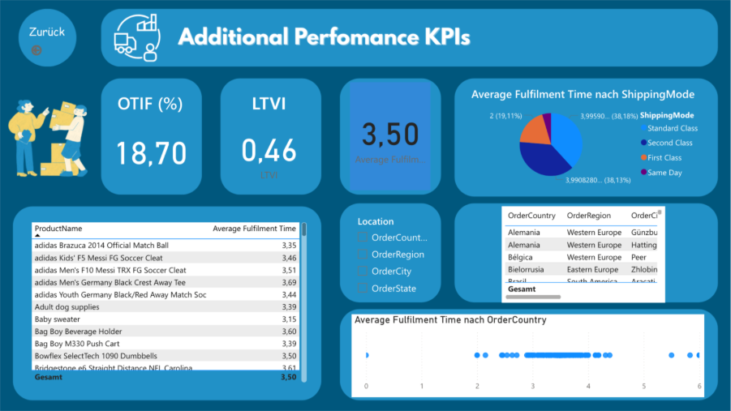
Figure X: Alpha version of the dashboard design.
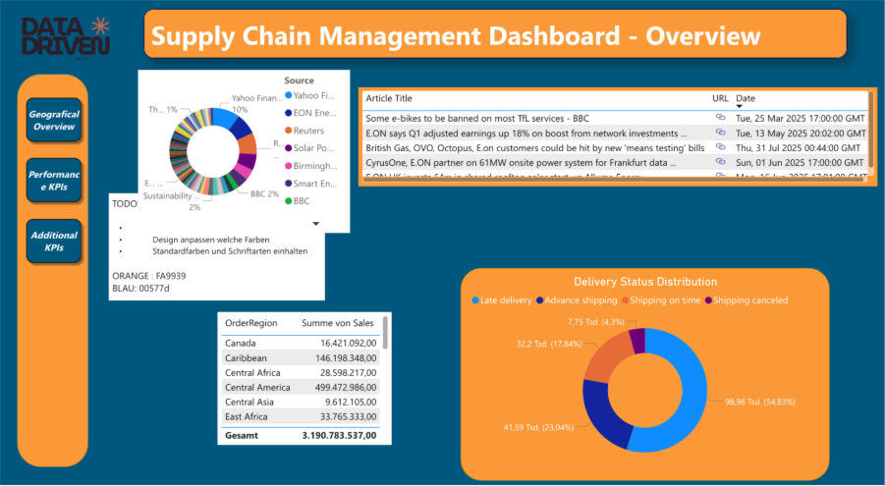
Figure X: Beta version of the dashboard design.
These variations explored alternative color schemes and layout structures, while backgrounds were specifically designed to establish a clean and uniform visual appearance across all pages of the dashboard.

Overview Dashboard (Semih)
The dashboard was conceptually structured into multiple pages, with the Overview Page designed as the central access point for stakeholders. Its purpose is to provide an aggregated and concise representation of the most critical metrics and contextual information before engaging with more detailed analyses on subsequent pages. The design rationale followed a user-centered perspective, with particular emphasis on decision-makers such as executives and managers.
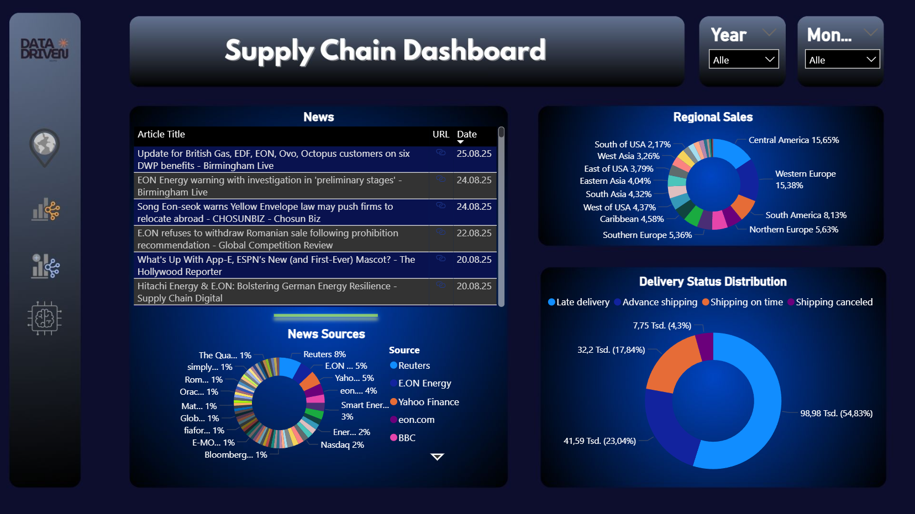
Figure X: Screenshot of Supply Chain Dashboard: Overview Page
Figure X shows the final design of the Overview Page. The elements on this page were selected based on a clear process for choosing the most relevant key performance indicators (KPIs), with the goal of making the information both meaningful and easy to interpret. In addition, the interactive filters ensure that changes in one visualization (for example, selecting a specific region) automatically update the related elements (such as the delivery status). This creates a connected and user-friendly analysis that adapts to the context of the data.
The navigation bar on the left side of the interface constitutes the central structural element of the dashboard. It allows direct access to the individual subpages through icon-based navigation, which was deliberately chosen to improve usability and to enhance the visual appeal of the user interface. In addition, filter elements located in the upper-right corner enable the selection of specific temporal dimensions (year and month), thereby supporting interactive and time-sensitive analysis of the underlying dataset.
The content of the Overview Page is organized into three key components. First, the integration of a news feed on the left side provides users with access to current external information sources. These articles, retrieved from Google News using the RSS feed functionality, are directly accessible through embedded links. A donut chart provides an overview and enables the selection of preferred news sources, thereby allowing the deliberate focus on especially relevant sources. This up-to-date information about recent events allows managers to contextualize operational performance with geopolitical or macroeconomic developments that may influence supply chain stability.
Second, the regional sales distribution is presented on the right side of the interface. The visualization highlights proportional sales volumes across different regions and thereby facilitates the identification of geographical differences in market performance. This allows decision-makers to allocate strategic attention and resources more effectively, for example by contrasting stronger performance in Central America with weaker performance in West Asia.
Third, the delivery status distribution provides a categorical breakdown of shipments, distinguishing between on-time deliveries, delayed shipments, shipments in progress, and cancellations. In combination with the temporal filters, this visualization enables longitudinal analysis of delivery performance and thus supports the identification of temporal trends and regional deviations in supply chain reliability.
In summary, the Overview Page is designed to give stakeholders a quick and clear view of the most important information. By combining external news with internal performance data, it offers a complete picture of the supply chain situation. The navigation bar and interactive filters make the dashboard easy to use and help users analyze the data in more detail.
Additional description of the news feed implementation (Alex)
In order to incorporate information about recent events and developments within the decision-support system, a news component was implemented and integrated into the dashboard.
Since Power BI does not provide an out-of-the-box solution for news integration, research had to be done on possible ways to incorporate relevant news into the Power BI dashboard (this research included the universities online library as well as a variation of different Google searches). The research results could be divided into two approaches. One approach would be to use RSS feed technology, the other approach would be to use an Application Programming Interface (in short: API). Since the RSS feed technology approach was deemed less complex in the implementation and therefore less prone to errors, it was chosen instead of the API approach. Instructions on how to load an RSS feed into Power BI could be found in web articles (e.g. Van der Vorst, F. (2023, 08.25). Implementing feeds in Microsoft Power BI. LinkedIn. https://www.linkedin.com/pulse/implementing-feeds-microsoft-powerbi-ferry-van-der-vorst/) as well as YouTube videos (e.g. Ptarmy. (2023, 07.06). Creating Live News Feeds in Power BI | Stock Research Dashboard. YouTube. https://www.youtube.com/watch?v=qoS7fltDioY).
First an URL to a news RSS feed had to be created. With regards to the proof-of concept, it was deemed sufficient to use a single RSS feed. For illustration purposes the RSS feed for news relating to the company “E.on” was chosen. E.on was selected because it is an international company and is frequently included in news articles.
The RSS feed “https://news.google.com/rss/search?q=e.on” was used as the input for “Get data”, “Web” functionality in Power BI. The results were loaded into Power BI and transformed into the desired form using Power Query, as shown in Figure 1 and in Figure 2.
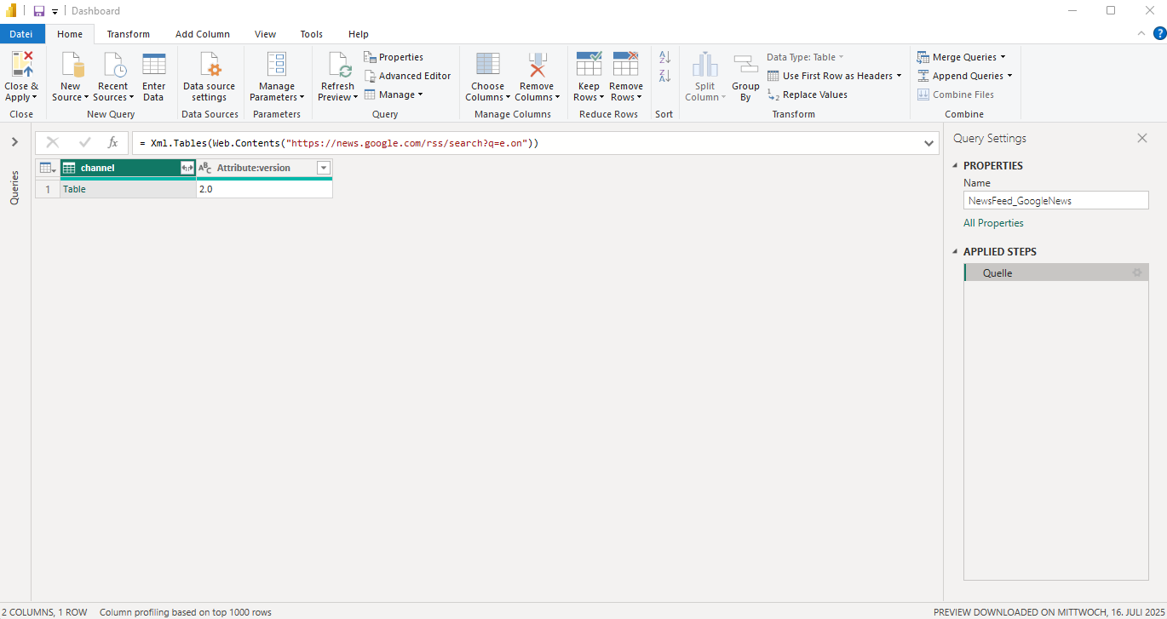
Figure 1: News Feed Data Loading in Power BI
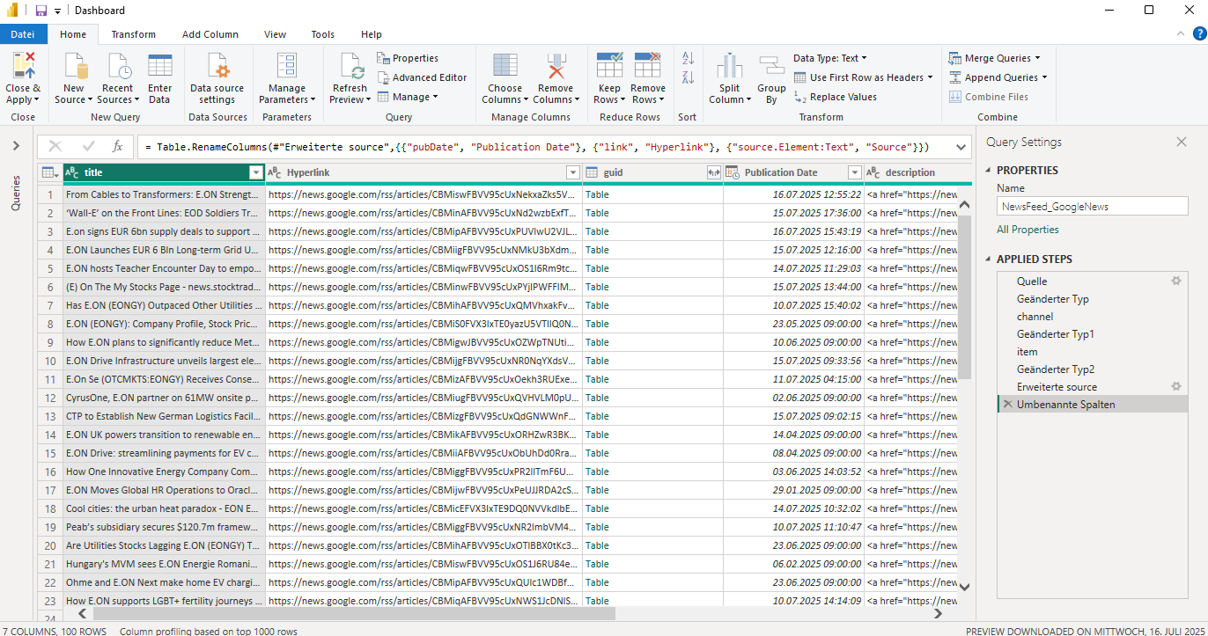
Figure 2: News Feed Data Transformation in Power Query

Geographical Overview (Alex)
The second dashboard page is “Geographical Overview”. As shown in Figure 3, it provides information in a geographical visualization.
In the upper half of the page, there are two geographical representations of the company’s business activities. The left visualization shows an interactive world map. In this all states with business activities are marked with different colors. Thereby, allowing the user to quickly grasp which parts of the world the company is doing business in. Building on this information, the user can assess possible disruptions of the supply chain by location-specific events (e.g. natural disasters or strikes). The upper right visualization also shows a world map. Instead of different states with business activities, it marks the intensity of business activities by automatically assigning different colors to different values. This data visualization is commonly known as a heatmap.
In the lower half of the page, there is a “Donut chart” visualization and a “Filter” table. The donut chart shows the total amount of orders categorized by the order region and allows the user to readjust the geographical visualizations with regards to specific regions. For example, if Central America is chosen in the donut chart, the visualizations readjust to the region of Central America, shown in Figure 4.
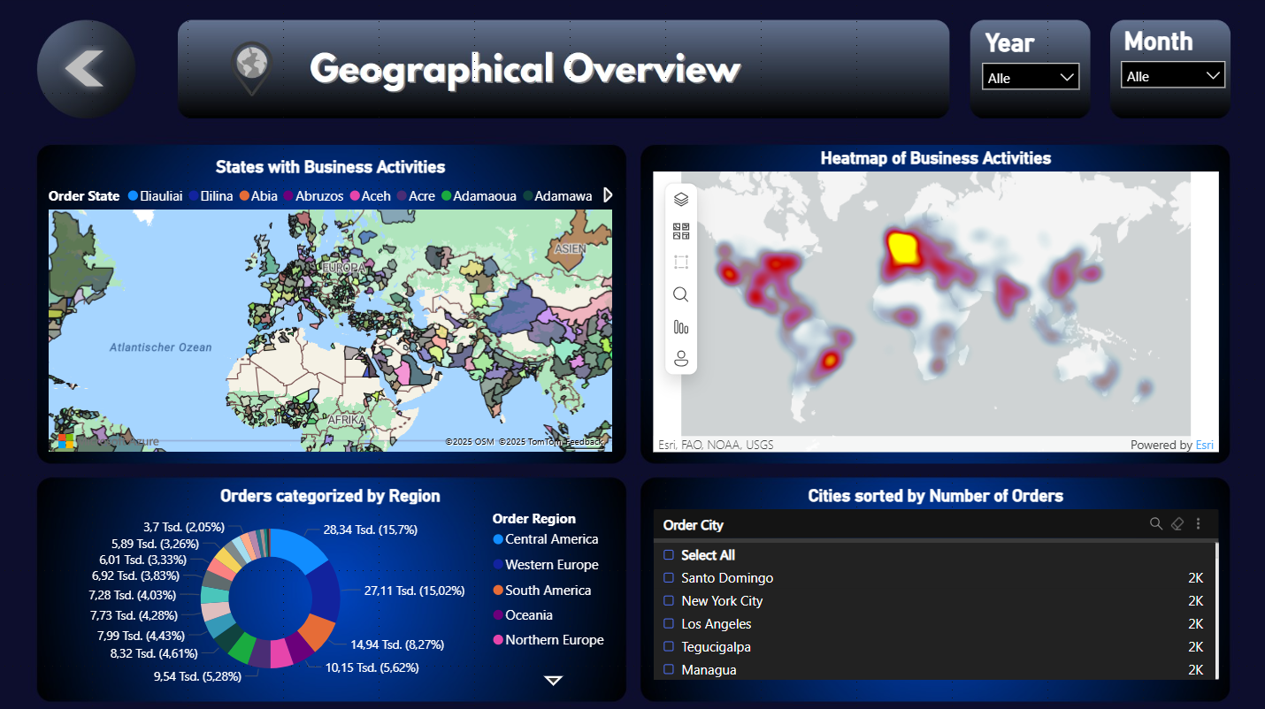
Figure 3: Dashboard Page – Geographical Overview
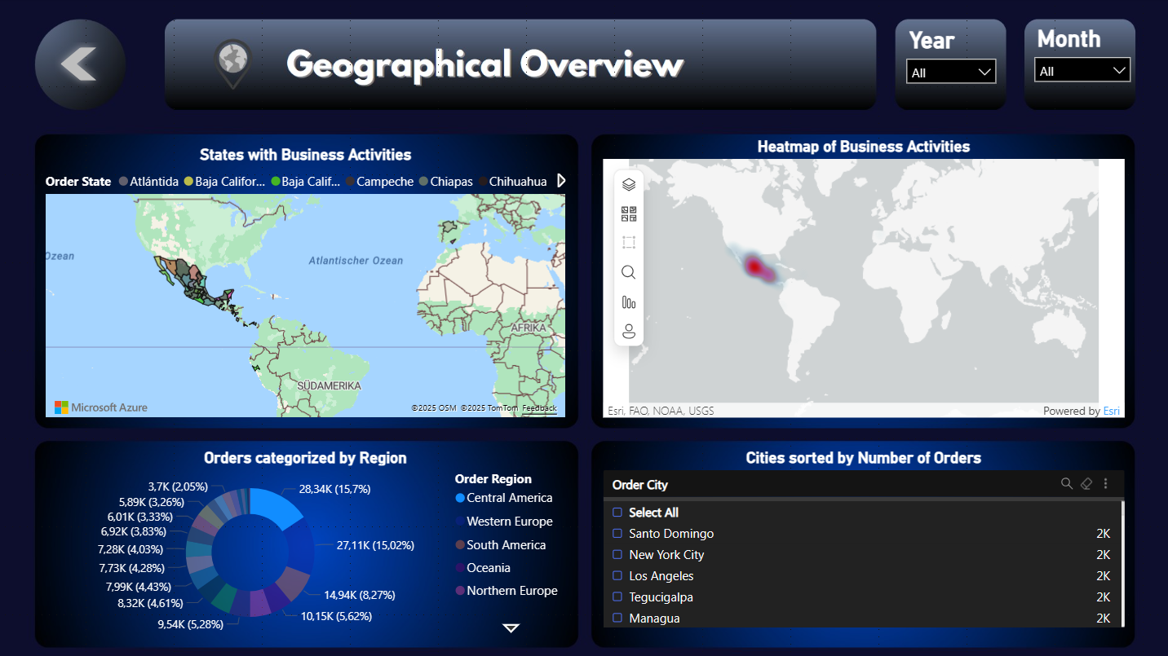
Figure 4: Geographical Overview readjusted to Central America
Additional description of the Geographical Overview implementation (Alex)
To create a meaningful visualization for the Geographical Overview, first the different functionalities and configuration options of available visualization elements in Power BI were examined to obtain an understanding of the capabilities and limitations of the respective elements. This included the elements “map”, “filled map”, “Azure map” and “ArcGIS for Power BI”. In the next step the elements were tested with different data input to determine a meaningful balance between not enough information and information overload. The visualization of Order City, Order State, Order Country and Order Region was tested. While visualization of Order City provided too much information and was hard to read, the visualization of Order Country and Order Region provided not enough information to meaningfully support decisions. Resulting in the choice of geographical visualization of Order States. Based on functional capabilities and personal preferences with regards to the visualization design, as final visualization elements “Azure map” and “ArcGIS for Power BI” were chosen and configured. Azure map was configured using “Order State” values for the setting “Location” as well as the setting “Legend”. ArcGIS for Power BI was configured using “Order City” values for the setting “Location” and “Order State” values for the setting "Color”.
While both geographical visualizations provide important location specific insights into the business activities, they are relatively static when used by themselves. Therefore, additional elements of Power BI were tested with the goal of improving their meaningfulness. For this purpose, different values and Power BI visualizations were tested in a similar way to the geographical visualizations (including additional Power BI elements from Microsoft’s AppSource). Based on the informative value and personal preferences with regards to the visualization design, “Donut chart” and “Filter” were chosen. Donut chart was configured using “Count of OrderId” values for the setting “Values” and “Order Region” for the setting “Legend”. Filter was configured using “Count of OrderId” values for the setting “Value” and “Order City” for the setting “Category”. Additionally, it was configured to sort the cities by the number of orders in a descending order.
Prospects for Geographical Overview
The geographical overview provides different location specific information. In this project, we focused on using the available information for this visualization. Further extensions of the geographical visualizations could contain additional information. For example, if the company’s delivery service uses order tracking technologies. Corresponding information could be integrated into the Geographical Overview further improving the meaningfulness of the dashboard. This would be especially relevant for companies with time-critical high-value order deliveries (e.g. deliveries of medical supplies to address medical emergencies or deliveries of machine parts to reduce downtime in factories). Additional information would provide additional possibilities for interactions with the data. Therefore, depending on the new information, the Donut chart visualization and the Filter table should be revised and improved or replaced to maintain their purpose of supplementing the geographical visualizations.

KPIs (Semih)
The KPI Page represents the second central component of the dashboard and is designed to provide stakeholders with a deeper insight into the most relevant performance indicators. While the Overview Page gives a general orientation, the KPI Page enables a more detailed examination of sales development, delivery reliability, and shipping performance. The navigation element in the top-left corner allows the user to return directly to the Overview Page at any time, ensuring intuitive navigation and a consistent user experience throughout the dashboard.
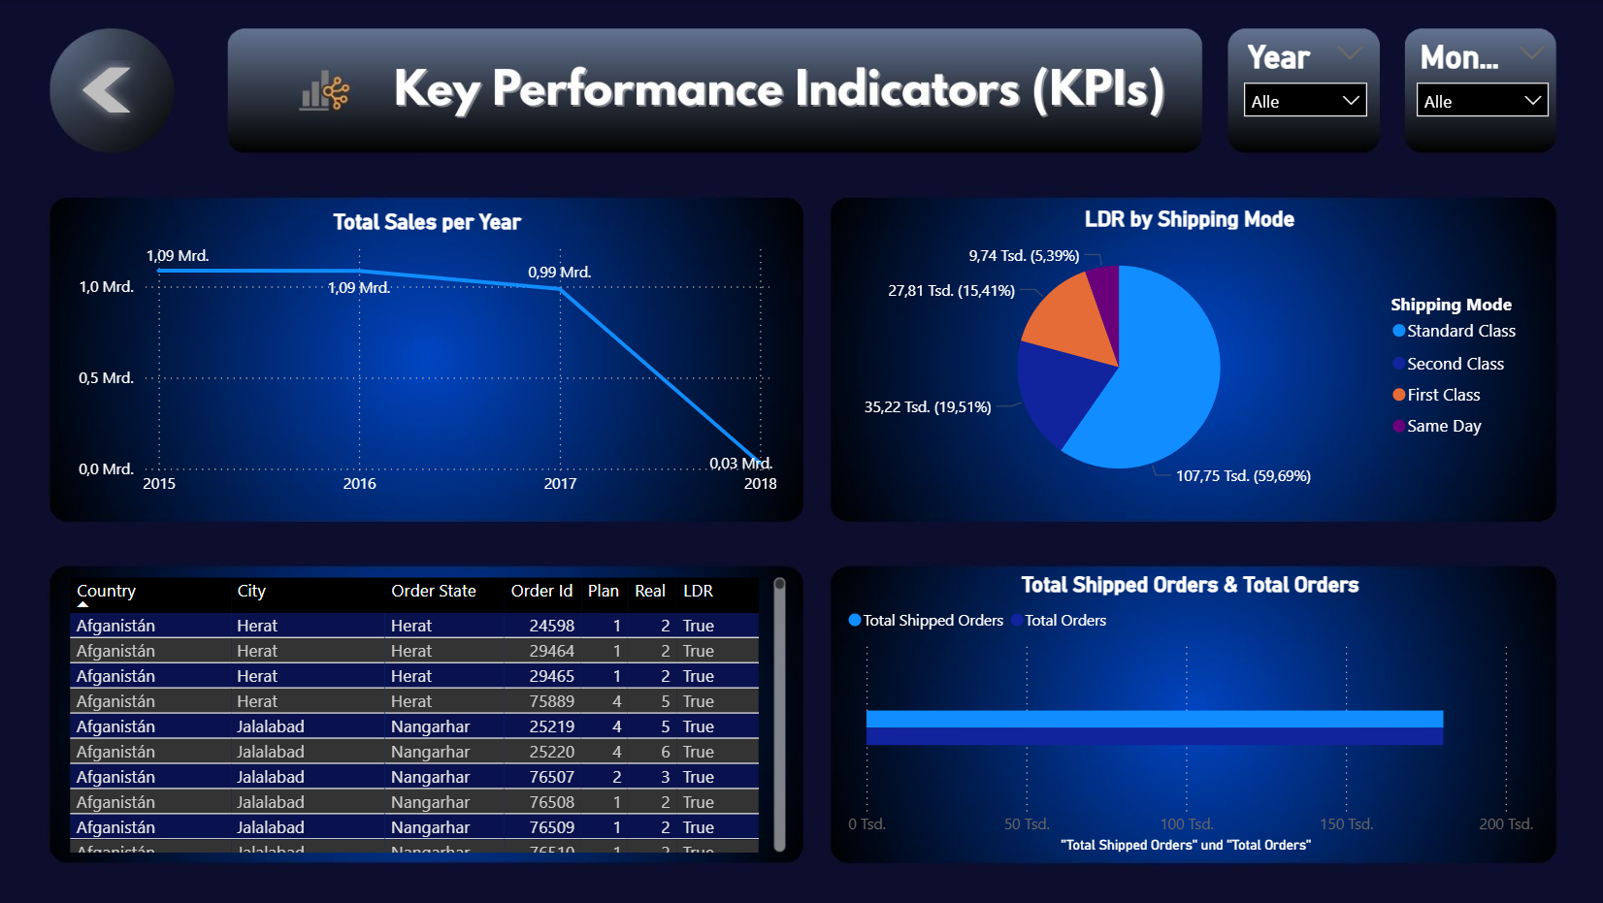
Figure X: Screenshot of Supply Chain Dashboard: Key Performance Indicators Page
In the top-left area, the visualization Total Sales per Year presents the revenue development across the years covered by the dataset. This line chart illustrates both stable and declining phases, allowing stakeholders to identify long-term trends in the company’s sales performance. The inclusion of this KPI was based on the idea that revenue development constitutes one of the most fundamental performance indicators for any company. By enabling filtering by year and month, users can not only detect seasonal fluctuations but also evaluate the long-term sustainability of the sales strategy.
The top-right visualization highlights the Late Delivery Risk (LDR) by Shipping Mode. We deliberately included this KPI because delivery reliability is a critical determinant of customer satisfaction and supply chain efficiency. By categorizing orders into different shipping modes (Standard Class, Second Class, First Class, and Same Day), the pie chart shows which modes are particularly vulnerable to delays. Our reasoning was that decision-makers need to understand not only whether delays occur but also in which operational channels they accumulate. For example, if most risks occur in Standard Class shipping, management can focus its resources on optimizing that mode rather than applying generic measures across all shipping categories.
The bottom-left section contains a detailed data table that lists individual orders together with relevant attributes such as country, city, order ID, planned and actual values, and delivery status. This table was implemented to ensure transparency and traceability. Our thought process here was to allow users to drill down into the raw data whenever needed. In practice, stakeholders may first observe an overall pattern in the visualizations and then use the table to investigate the concrete cases behind those patterns. In this way, the table bridges the gap between aggregated KPIs and operational details.
The bottom-right visualization compares Total Shipped Orders with Total Orders. We decided to include this KPI because it provides an immediate measure of fulfillment efficiency. For stakeholders, it is essential to know how many orders were actually processed compared to total demand, as this reflects the operational reliability of the supply chain. The bar chart offers a direct and easy-to-interpret indicator that complements the more complex measures of delivery risk.
Overall, the design of the KPI Page was guided by the principle of combining strategic indicators (such as total sales) with operational indicators (such as LDR or shipped orders). This ensures that decision-makers can move seamlessly from a high-level perspective to detailed operational insights. The interactive filters for year and month further enhance the analytical depth by allowing comparisons across different time horizons. Our intention was to create a page that not only reports on performance but also supports managerial decision-making by highlighting where risks and inefficiencies in the supply chain are concentrated.

Additional KPIs (Sarah)
A separate additional KPI dashboard was developed to provide further insight into supply chain performance using a targeted set of indicators. This dashboard is intended to complement the main analysis by focusing on additional metrics that capture specific aspects of operational reliability and efficiency. The following section presents the design, calculation principles, and visualization approach for this additional KPI dashboard.
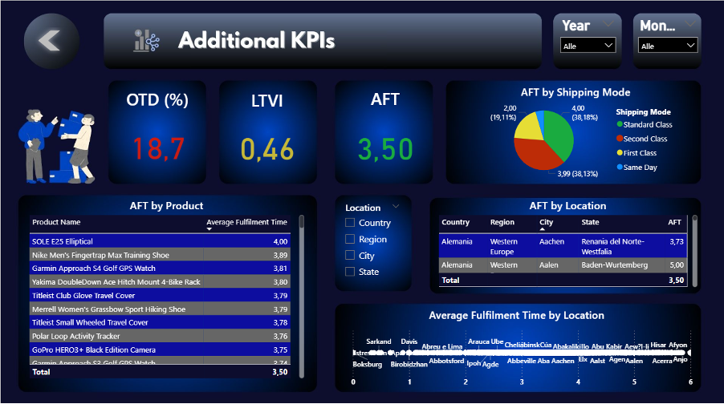
The additional KPI dashboard focuses on three performance metrics relevant to supply chain monitoring: On-Time-Delivery (OTD), Lead Time Variability Index (LTVI), and Average Order Fulfillment Time (AFT). The dashboard was created using Power BI for all data visualizations, with the overall background and visual layout designed in Canva. These KPIs were selected for their ability to reflect supply chain performance, reliability, and operational efficiency, and they are presented through both summary metric cards and detailed breakdowns to support targeted analysis.

On-Time-Delivery (OTD)
On-Time Delivery (OTD), is defined by the American Productivity & Quality Center (APQC) as a measure determines the percentage of supplier orders delivered on time as scheduled. "On time" for this purpose is defined by the agreed delivery time. It is part of a set of Process Efficiency measures that help companies optimize the performance of their "manage logistics and warehousing" process by minimizing waste and refining resource consumption (APQC, 2024). OTD is widely recognized as a visibility measure for supply chain performance, since deviations directly indicate declining reliability. In fact, Wieland and Wallenburg (2013) emphasize that visibility is a critical mechanism of supply chain resilience, enabling early detection of disruptions in sourcing, production, or logistics. Thus, a reduction in OTD can reasonably be interpreted as one of the earliest measurable signs of disruption in supply chain processes.
The metric is calculated as the number of on-time and complete deliveries divided by the total number of shipped orders, expressed as a percentage. An order is classified as on-time when the actual shipping days match the scheduled shipping days, and as complete when the delivered quantity matches the ordered quantity. The relevant data sources for this KPI are DimDate (order, shipping, and arrival dates), DimShipping.ShippingDays (planned delivery windows), and FactOrderItem.Quantity (comparison of ordered and delivered quantities). OTD is widely recognized in both academic and industry contexts as a core indicator of process efficiency and supply chain resilience (APQC, 2024; Wieland & Wallenburg, 2013).
It calculates the percentage of orders delivered both on time and in full by dividing the number of on-time orders by the total number of shipped orders and then multiplying by 100. The On-Time Delivery (OTD) / On-Time In-Full (OTIF) KPI is implemented in Power BI using a DAX measure:
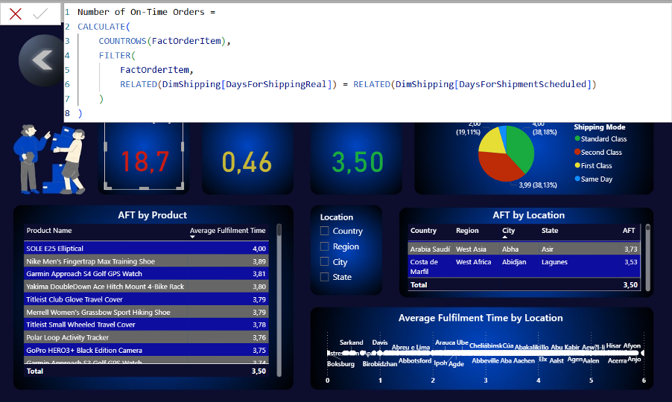

Lead Time Variability Index (LTVI)
The Lead Time Variability Index (LTVI) captures fluctuations in delivery lead times across product × supplier × route combinations. In practice, it refers to the variation in the time required for materials or goods to arrive from a supplier to the company’s warehouse or receiving location. Factors such as supplier reliability, transportation delays, and customs clearance can all contribute to lead time variability (Lark Suite, 2024).
Higher variability typically necessitates maintaining greater levels of safety stock to avoid stockouts. Industry sources confirm that longer and less predictable lead times increase inventory requirements (Log-hub, 2024). Academic studies also show that lead time variability critically affects operational efficiency, cost management, and service delivery (Mohammed & Mandal, 2024). In general, high variability reduces planning accuracy, increases the need for buffer inventory, and raises the risk of part shortages.
In this project, LTVI is calculated as the coefficient of variation of lead time, i.e., the ratio of the standard deviation of lead times to the average lead time. This approach follows standard supply chain formulations, where lead-time variance directly enters safety stock calculations (MIT CTL, Lead Time Variability & Mode Selection). Planned lead times are obtained from DimShipping.ShippingDays, while actual lead times are calculated from DimDate by subtracting the order date from the arrival date. The measure can be grouped by supplier or region to identify areas with particularly high variability.
Findings indicate that higher lead time variability leads to increased inventory costs, greater risk of stockouts, and delays in product deliveries. Both academic and industry research confirm that high lead time variability correlates strongly with increased costs and reduced service levels (Christensen, Germain, & Birou, 2005; Mohammed & Mandal, 2024).

It calculates the coefficient of variation of lead times, i.e., the ratio of the standard deviation of delivery lead times to their average. This allows variability to be expressed relative to the mean lead time, making comparisons across suppliers, products, or routes more meaningful. The Lead Time Variability Index (LTVI) is implemented in Power BI using this DAX measure:
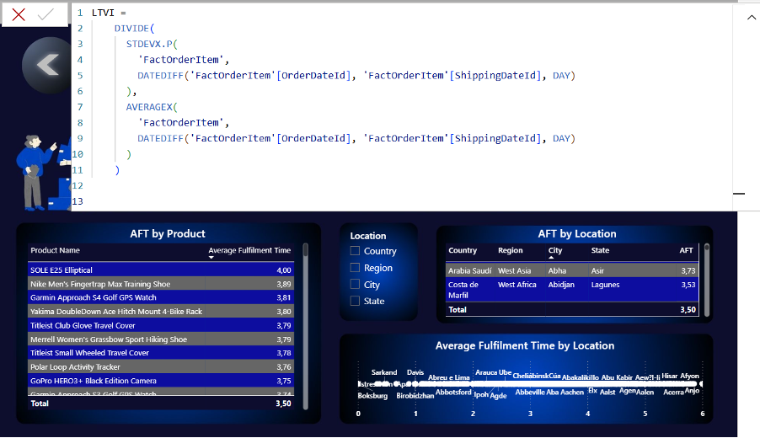
Average Fulfillment Time (AFT)
Average Fulfillment Time (AFT) measures the average duration from order placement to delivery to the customer. In this project, we define AFT as the average number of days from order placement to delivery. This corresponds to the Order Fulfillment Cycle Time or Total Order Cycle Time commonly used in industry and academic literature (SCOR, 2012; NetSuite, 2021; Amazon Supply Chain, n.d.). Order fulfillment refers to the process of completing a sales order according to customer specifications and delivering goods as promised. As consumers increasingly move online to shop, the importance of efficient order fulfilment processes continues to grow (NetSuite, 2021).
The formula calculates, for each order, the number of days between the order date and the shipping date and then averages these values across all orders to produce the Average Fulfilment Time. To operationalize this KPI in Power BI, we implemented this DAX measure:
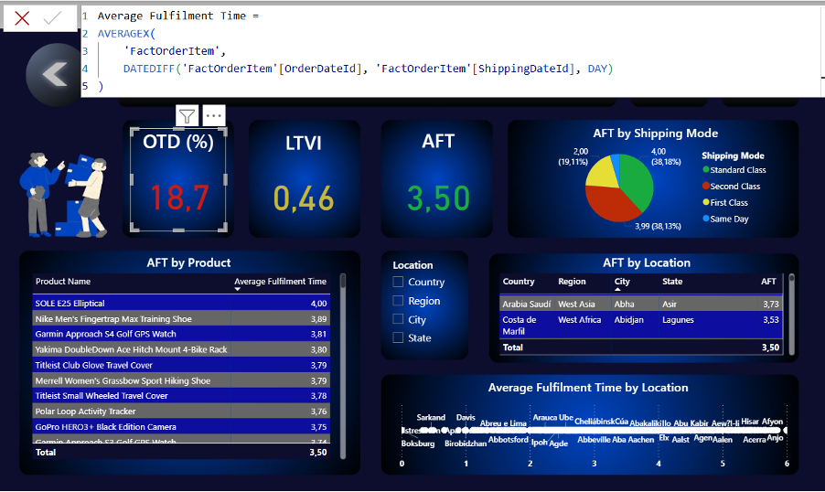
Color-Coding Rules for KPI-Cards
Each KPI is displayed as a card at the Top of the dashboard, supported by a color-coding scheme for immediate interpretation.
OTD:
Industry guidelines consistently highlight that OTD rates below 95 % suggest operational issues, while top performers (especially in e-commerce and B2B logistics) target 95 % or higher. For instance, UpperInc reports that in sectors like manufacturing supply chains, a delivery rate below 90 % generally signals systemic operational issues requiring immediate attention; top-performing operations aim for ≥ 95 % to stay competitive. (UpperInc, 2025)
Therefore:
≥ 95% and < 100% → Green (Good)
≥ 85% and < 94% → Orange (Acceptable)
≥ 0% and < 85% → Red (Needs improvement)
Current value: 18.7% → Red
LTVI:
As explained in the LTVI section above, this KPI is measured as the coefficient of variation of lead time (σ/μ), where values closer to zero indicate higher consistency and predictability (MIT CTL, Lead Time Variability & Mode Selection). A current value of 0.46 places us near the midpoint of the scale, suggesting a level of performance that is moderate and stable but not yet optimal, but also not alarming, and clearly positioned within an acceptable range.
Therefore:
0 ≤ value ≤ 0.4 → Green (Low variability)
0.4 < value ≤ 0.6 → Yellow (Moderate variability)
0.6 < value ≤ 1 → Red (High variability)
Current value: 0.46% → Yellow
AFT:
In this project, we define efficient performance as an Average Fulfillment Time (AFT) within a 3–5-day window. This range is commonly cited in industry practice for e-commerce and consumer goods supply chains (NetSuite, 2021; Amazon Supply Chain, n.d.), though optimal cycle times can vary by sector. Our current value of 3.5 days falls comfortably within this efficient range. Anything exceeding this range suggests increasing inefficiency. Therefore, our current average of 3.5 days sits comfortably within the optimal range, signaling a strong (green) performance in this area.

0 ≤ value < 6 days → Green (Efficient)
6 ≤ value < 11 days → Yellow (Moderate)
11 ≤ value ≤ 50 days → Red (Inefficient)
Current value: 3.5 days → Green

Detailed Breakdowns for AFT
The dashboard includes interactive breakdowns of the AFT metric to enable more granular analysis. AFT by shipping mode is presented as a pie chart, with categories such as standard class, second class, first class, and same day. Selecting a segment of the chart filters the dashboard to display AFT data for the chosen shipping mode. AFT by location is displayed as a table containing hierarchical filters for country, region, city, and state; clicking on an entry filters the displayed data accordingly. AFT by product is also presented in table format, listing product names alongside their corresponding average fulfillment times.

ML-based Predictions (Alex)
The last dashboard page is “ML-based Predictions”. As shown in Figure 5, it provides visualizations of predicted data. In the upper left corner, the total amount of “All Deliveries” as well as “Late Delivery Predictions” is provided. Those values are important because they show how big the data set of deliveries was, to create the respective amount of late delivery predictions. Below those two numbers there is a “Clustered column chart” visualization of the top five product categories based on their respective total amount of predicted late deliveries. In the lower left corner, there is a table of the “Predicted Demand by Country & Category”. This table enables the company to understand future demand and makes it possible to include future demands in the planning processes. For example, if the second largest future demand falls within the product category “Cleats”, while “Cleats” is also the product category with the highest risk for late deliveries, the company can implement measures to improve the supply chain for cleats, thereby reducing the risk of late deliveries. In the upper right corner, there is a “Line chart” of the “Predicted Sales over Time”. It shows the total amount of sales based on the predicted demand. In the lower right corner, there is a “Pie chart” of the predicted sales clustered by country in a descending order. This visualization shows the countries with the highest predicted sales amount and at the same time, it serves as a filter to allow the consideration of country specific top five late delivery categories as well as country specific predicted sales over time.
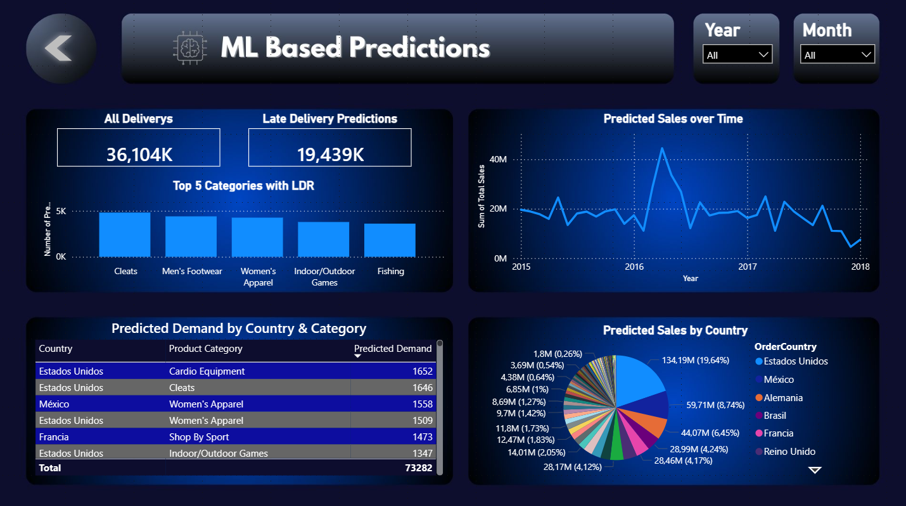
Figure 5: Dashboard Page – ML-based Predictions
Additional description of the ML-based Predictions implementation (Alex)
To create a meaningful visualization for the predicted values, similar to the other dashboard pages, it was important to examine and test the different functionalities and configuration options of available visualization elements in Power BI in combination with the predicted values. For this purpose, the predicted values were visualized using different Power BI visualizations and the results were tested and discussed. Based on the informative value and personal preferences with regards to the visualization design, “Clustered column chart”, “Table”, “Line chart” and “Pie chart” were chosen. Clustered column chart was configured using “Category Name” values for the setting “X-axis” and “Number of Predictions” for the setting “Y-axis”. The table was configured using “Country”, “Product Category” and “Predicted Demand” values from our demand prediction data for the setting “Columns”. Line chart was configured using “YearMonth” values for the setting “X-axis” and “Sum of Total Sales” for the setting “Y-axis”. Pie chart was configured using “Sum of Total Sales” values for the setting “values” and “Order Country” values for the setting "Legend”.
Prospects for ML-based Predictions
The “ML-based Predictions” page provides different predicted values by pre-trained machine learning models. In this project, the focus lies on the prediction of late deliveries and future demand as well as information that could be derived from those values (e.g. predicted sales). Even though those values are beneficial for supply chain management, more predictions could be implemented to provide a holistic view on possible future developments. Extensions of the predictions could contain additional information. Furthermore, the focus was on traditional machine learning models to generate predictive insights based on structured features extracted from the dataset. While this approach provides a strong baseline, traditional machine learning models are limited in their ability to capture complex, non-linear relationships across heterogeneous inputs. For future work, a multi-input neural network architecture implemented using TensorFlow’s Functional API could be considered. Such a model would enable the integration of diverse data modalities (e.g., numerical features, categorical encodings, and temporal sequences) into a unified learning framework. This approach would allow the network to process each input type through specialized subnetworks before combining them in a joint representation, thereby potentially improving predictive accuracy and generalizability. At the same time, it would require adjusting or replacing the current visualizations to maintain the useability and the meaningfulness of the dashboard.

Carneiro, T., da Nóbrega, R. V. M., Nepomuceno, T., Bian, G.-B., de Albuquerque, V. H. C., & Rebouças Filho, P. P. (2018). Performance analysis of Google Colaboratory as a tool for accelerating deep learning applications. IEEE Access, 6, 61677–61685. https://doi.org/10.1109/ACCESS.2018.2874767
Hilprecht, B., Binnig, C., & Röhm, U. (2019). Learning a partitioning advisor with deep reinforcement learning. arXiv preprint arXiv:1904.01279. https://arxiv.org/pdf/1904.01279
Hsu, C.-H., Xu, M., Cao, H., Baghban, H., & Ali, A. B. M. S. (Eds.). (2023). Big data intelligence and computing: International Conference, DataCom 2022, Denarau Island, Fiji, December 8–10, 2022, Proceedings (Lecture Notes in Computer Science, Vol. 13864). Springer Nature Singapore. https://doi.org/10.1007/978-981-99-2233-8
Komati, S. (2023). DataCo supply chain dataset. Kaggle. Retrieved August 5, 2025, from https://www.kaggle.com/datasets/saicharankomati/dataco-supply-chain-dataset
Krizhevsky, A., Sutskever, I., & Hinton, G. E. (2012). Imagenet classification with deep convolutional neural networks. arXiv preprint. https://arxiv.org/pdf/1102.1523
Microsoft. (n.d.-a). Create a database schema. Microsoft Learn. Retrieved August 5, 2025, from https://learn.microsoft.com/en-us/sql/relational-databases/security/authentication-access/create-a-database-schema
Microsoft. (n.d.-b). Create unique constraints. Microsoft Learn. Retrieved August 5, 2025, from https://learn.microsoft.com/en-us/sql/relational-databases/tables/create-unique-constraints
Microsoft. (n.d.-c). Start the SQL Server import and export wizard. Microsoft Learn. Retrieved August 5, 2025, from https://learn.microsoft.com/en-us/sql/integration-services/import-export-data/start-the-sql-server-import-and-export-wizard
Mohammed, K. I. (2019). Data warehouse design and implementation based on star schema vs. snowflake schema. International Journal of Academic Research in Business and Social Sciences, 9(14), 25–38. https://doi.org/10.6007/IJARBSS/v9-i14/6502
Pandas Development Team. (n.d.). pandas: Python data analysis library. Retrieved August 5, 2025, from https://pandas.pydata.org
Radford, A., Wu, J., Child, R., Luan, D., Amodei, D., & Sutskever, I. (2019). Language models are unsupervised multitask learners. arXiv preprint. https://arxiv.org/pdf/1904.01279
Talwar, S., Kaur, P., Wamba, S. F., & Dhir, A. (2021). Big data in operations and supply chain management: A systematic literature review and future research agenda. International Journal of Production Research, 59(11), 3509–3534. https://doi.org/10.1080/00207543.2020.1868599
Van der Walt, S., Colbert, S. C., & Varoquaux, G. (2011). The NumPy array: A structure for efficient numerical computation. IEEE Computing in Science & Engineering, 13(2), 22–30. https://doi.org/10.1109/MCSE.2011.37 (Original work on arXiv:1102.1523)
Vijayendra, N., & Lu, M. (2013). A web-based ETL tool for data integration process. In 2013 IEEE International Conference on Human System Interactions (HSI) (pp. 434–439). IEEE. https://doi.org/10.1109/HSI.2013.6577861
Xu, J., Pero, M., & Fabbri, M. (2023). Unfolding the link between big data analytics and supply chain planning: A Delphi study. Technological Forecasting & Social Change, 196, 122805. https://doi.org/10.1016/j.techfore.2023.122805

Findings
- Insights from our data or system
- Evaluation of the results (e.g. through tests, user tests, interviews)
  - Performance metrics (accuracy, speed, etc.)
  - Outcomes of tests, simulations, or user feedback
- Observed trends, patterns, or anomalies

Discussion and conclusion

Summary of the findings
The results of this project underline the considerable potential of machine learning for advancing predictive analytics as part of data-driven decision support systems in the supply chain management domain. By addressing two complementary challenges – predicting late delivery risks through classification and forecasting product demand through regression – the analysis provides a comprehensive view of how predictive models can support both operational reliability and strategic planning.
Theoretical Implications
Although this proof-of-concept primarily aimed at demonstrating feasibility, it also generates several theoretical insights that extend current discussions in the fields of decision-support systems, information systems design, and socio-technical system research. These implications emerge not from the prototype’s practical outcomes alone but from its limitations, boundary conditions, and the ways it reflects the interplay between technology and organizational use.
This proof-of-concept illustrates how dashboards, predictive analytics, and contextual information can be combined into an integrated decision-support artifact. While the implementation remained simplified, it highlights critical design choices regarding feature selection, data granularity and user interaction. This contributes to design theory (Gregor & Hevner, 2013, p. 338) by demonstrating how feasibility-driven prototypes act as boundary objects that help identify which design principles (e.g., real-time visualization, drill-down capabilities, interpretability of ML outputs) are central for managerial usability. It reinforces the argument that decision-support systems must be studied not only as functional tools but also as artifacts that shape cognitive and organizational processes.
- Gregor, S., & Hevner, A. R. (2013). Positioning and presenting design science research for maximum impact. MIS Quarterly, 37(2), 337–355. https://doi.org/10.25300/misq/2013/37.2.01
Business and Managerial Implications
Beyond technical performance, the results hold implications for managerial practice. Predictive models can fundamentally reshape how managers approach supply chain planning. Instead of relying solely on historical averages and heuristics, decision-makers can use forward-looking risk and demand predictions to optimize operations. This transition represents a shift from reactive to proactive management, consistent with broader trends in digital transformation and “Supply Chain 4.0” (Breusch, Michael (2020), p. 71-76). Furthermore, predictive analytics can be leveraged not only for operational efficiency but also for strategic advantage. For example, companies that can more accurately forecast demand may gain leverage in negotiations with suppliers, optimize pricing strategies, and respond more effectively to market changes. Similarly, companies that can anticipate delivery delays may be better positioned to manage customer expectations and preserve brand reputation.
- Breusch, Michael (2020). Supply Chain 4.0 – Voraussetzungen für die Digitalisierung in der Lager- und Transportlogistik. In P. H. Voß (Ed.), Logistik – die unterschätzte Zukunftsindustrie (pp. 71–76). Springer Fachmedien Wiesbaden. https://doi.org/10.1007/978-3-658-27317-0_6
Sustainability and Ethical Perspectives
Accurate demand forecasting can reduce waste by minimizing overproduction and unsold inventory. At the same time, improved delivery reliability reduces unnecessary transportation and rescheduling, contributing to lower emissions. These aspects align predictive analytics with sustainability goals, an increasingly critical concern for both companies and regulators.
From an ethical standpoint, predictive models must be deployed responsibly to ensure transparency and fairness. While this project did not directly address issues of bias, future implementations should consider how data-driven decisions affect stakeholders across the supply chain. Explainable AI techniques, such as SHAP values (Mishra, P. (2003), p. 1-3), could enhance transparency and build trust among decision-makers, employees and customers.
- Mishra, Pradeepta (2023). Explainable AI recipes: implement solutions to model explainability and interpretability with Python (1st ed. 2023.) (p. 1-3). Apress Media LLC. https://doi.org/10.1007/978-1-4842-9029-3
Future Perspectives
The potential for future development of these models is considerable. One promising avenue is the integration of classification and regression models into a unified decision-support system. By simultaneously predicting delivery risks and demand fluctuations, companies could align their logistics planning with expected demand, creating a more resilient and adaptive supply chain.
Another opportunity lies in the incorporation of real-time data streams, such as IoT sensor information, GPS tracking of shipments, or economic indicators. These additions would allow models to adapt dynamically to changing conditions, further enhancing predictive accuracy.
Finally, the models presented here contribute to the broader vision of autonomous supply chains, in which predictive analytics, automation, and AI-based decision-making systems work together to create self-adjusting networks. In this sense, the project provides a concrete example of how machine learning can support the transition toward smarter, more resilient supply chain ecosystems.
Overall, the findings underline the transformative role of predictive analytics in modern supply chain management and point to a future in which data-driven intelligence is embedded at the core of business operations.

Interpretation of the findings
Reflection of the results in relation to the research questions

Limitations and future research
This proof-of-concept project provides valuable insights into feasibility and technical requirements of data-driven decision processes. However, it also has limitations that affect the results validity, scalability and practical use in organizational contexts. This chapter analyzes those limitations, focusing on the project (sub-)objectives “Dashboard”, “ML-based Predictions” and “System Architecture”. The limitations of those objectives are discussed with regards to the aspects “Scope, Scale & Data”, “Methodology” and “Generalization & Practicality”. An abbreviated overview is provided in Figure 6.
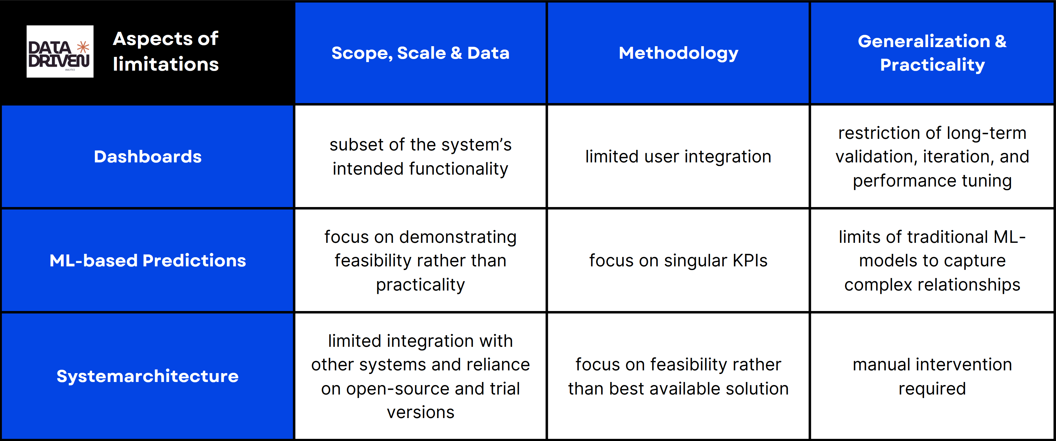
Figure 6: Limitations of the project results

Dashboard limitations
Even though the KPIs in the dashboard were chosen by managerial relevance, the selection was restricted by data availability. While effective for demonstration, such narrowing introduces three limitations. First, the prototype dashboard relies on cleaned and pre-aggregated datasets. This simplifies visualization but conceals the challenges of real-world data integration, such as missing values, semantic inconsistencies and siloed information systems. For instance, customer satisfaction metrics might be drawn from a single channel, ignoring cross-platform feedback that complicates interpretation. Second, the dashboard represents only selected business processes (e.g., sales and logistics), leaving out cross-functional interconnections that are essential for holistic decision-making. As a result, managers cannot assess trade-offs between interdependent domains (e.g., how supply chain delays affect sales targets). Third, enterprise-level dashboards must process millions of data points from a variety of systems in regular intervals, in some cases even in near real-time, but the dashboard in this project simulates a smaller-scale procession using preprocessed datasets. This masks scalability challenges such as query optimization, data latency, and storage constraints. Together, these restrictions reduce the epistemic reliability of the dashboard, limiting its role to an illustrative visual prototype rather than an operational decision-support system.
Methodologically, the dashboard in this project prioritizes feasibility over specificity. Its evaluation focused on visual appeal and immediate usability, lacking systematic testing of cognitive and decision outcomes. For example, the usability tests were conducted with only a small group of sympathetic stakeholders (mainly the members of the project team), creating selection bias. For the same reason, the interaction design remains premature, with limited attention to user customization, drill-down functionality, or alert mechanisms. Consequently, the dashboard in this project provides weak evidence regarding its actual contribution to decision effectiveness.
Generalization of the dashboard beyond the proof-of-concept could be hindered by its missing account for maintenance, update cycles, or user training. For instance, updating the dashboard with new KPIs may require re-engineering the data pipeline, a challenge not extensively addressed in this proof-of-concept. Additionally, this dashboard assumes rational decision-making and neglects cultural, political, and behavioral dimensions. A dashboard highlighting underperformance, for example, may be resisted due to perceived accountability risks. As a result, the dashboard in this project demonstrates visualization capabilities with limited evidence for large-scale, sustainable adoption.
ML-based Predictions limitations
In this project, the focus lies on the prediction of late deliveries and future demand as well as information that could be derived from those values (e.g. predicted sales). Even though those values are beneficial for supply chain management, more predictions could be implemented to provide a holistic view on possible future developments. Extensions of the predictions could contain additional information. The restricted scope limits not only predictive accuracy but also the robustness of insights, reducing the dashboard’s reliability as a decision-support instrument.
Furthermore, the focus was on traditional machine learning models to generate predictive insights based on structured features extracted from the dataset. While this approach provides a strong baseline, traditional machine learning models are limited in their ability to capture complex, non-linear relationships across heterogeneous inputs. For future work, a multi-input neural network architecture implemented using TensorFlow’s Functional API could be considered. Such a model would enable the integration of diverse data modalities (e.g., numerical features, categorical encodings, and temporal sequences) into a unified learning framework. This approach would allow the network to process each input type through specialized subnetworks before combining them in a joint representation, thereby potentially improving predictive accuracy and generalizability. At the same time, it would require adjusting or replacing the current visualizations to maintain the useability and the meaningfulness of the dashboard.
Methodologically, the focus on prediction of late deliveries and future demand using traditional machine learning models provides a strong initial point for the proof of feasibility. While the proof of reliability is highly restricted because of the limited test data as well as the missing tests in real-life environments.
Generalizing ML-based predictions from this project to real-world settings faces multiple obstacles. The models were trained on data from a single data source. Therefore, they may not generalize to another context due to differences in customer behavior, operational practices, or regulatory conditions. Managers are likely to resist adopting “black-box” predictions, particularly when accountability for high-stakes decisions is at stake. Deploying ML models requires pipelines for monitoring, retraining, and updating, which are not addressed in this project. Consequently, the ML-based predictions in the dashboard of this project should be viewed as an exploratory experiment rather than a ready-to-use decision-support feature.
System architecture limitations
The current system architecture is minimalistic and designed to showcase a specific case of application. This entails several limitations. It was tested on small loads and cannot demonstrate performance in real-life environments with multi-user conditions access. Changes in the overall architecture, e.g. because of software updates or product changes, were not included in the tests.
Methodological limitations in the system architecture result from the emphasis on feasibility and availability. Software products that would require financial investments were not considered because of the resource limitation of this project. Thereby limiting the product selection to cost-free test accounts and freeware products. The success of the system was measured by whether the dashboard was functioning rather than by assessing scalability, resilience, or compliance. Additionally, security aspects such as encryption, access control, and regulatory compliance were not addressed, except for the built-in security features of the system components. Resulting in the systems architecture being rather a conceptual prototype than a viable system design for a market ready product.
Architectural generalization is limited because the system in this project neglects certain aspects that are of lower priority for the proof-of-concept, like the integration of existing organizational systems (e.g. the complexity of interconnecting heterogeneous legacy systems). Regulatory compliance with location specific laws and regulations (e.g., General Data Protection Regulation, audit trail) was also unnecessary for the proof-of-concept system architecture, however, it becomes essential in production environments, especially for international organizations. This creates a gap between the system architecture in this project and the system architecture for a market ready product.
Future research
Although the dashboard in this proof-of-concept project is valuable for demonstrating feasibility and highlighting stakeholder-specific benefits, it is insufficient as evidence of operational effectiveness. Future work should therefore move beyond proof-of-concept toward systematic pilot studies, extensive evaluations and enterprise-scale implementations.
Future research could improve the robustness of the ML-based prediction validation by training on large-scale, longitudinal datasets, benchmarking across multiple domains, and testing in real-life environments. Additionally, organizational readiness for predictive analytics – covering skills, processes, and governance structures – could be studied to address the gap between technical feasibility and managerial adoption.
Furthermore, future research could assess the system architecture on quality attributes such as performance, security and governance. Case studies and design science approaches could provide empirical insights into how the system architecture can evolve from a proof-of-concept to a market ready product.

Conclusion
The proof-of-concept presented in this project demonstrates that supply chain data, when combined with predictive analytics and KPI-driven visualization, can provide actionable insights to support data-driven decision-making. By integrating machine learning models for demand forecasting and late delivery prediction with a dashboard interface, the project illustrates how organizations can transition from reactive operational management to proactive, evidence-based strategies. This aligns directly with the research objective of showcasing the potential of supply chain data to inform decision-making in a structured, visually interpretable format.
Beyond this immediate demonstration of feasibility, the project carries broader theoretical and practical significance. From a theoretical perspective, it reinforces the notion that decision-support systems are not merely functional artifacts but cognitive tools that shape managerial reasoning, prioritization, and strategic planning. The findings suggest that feasibility-driven prototypes can serve as boundary objects, offering researchers and practitioners a lens to examine design principles such as data granularity, real-time visualization, interactivity, and interpretability of machine learning outputs. They also underscore the importance of socio-technical considerations, showing that adoption is contingent not only on technical performance but also on organizational culture, trust, and accountability structures.
From a managerial perspective, the project underscores the transformative potential of predictive analytics in supply chain management. By providing forward-looking insights, managers can optimize inventory, improve operational reliability, and enhance strategic negotiation with suppliers. The combination of predictive modeling and KPIs supports a more holistic, proactive approach to decision-making, demonstrating that data-driven intelligence can influence both day-to-day operational choices and longer-term strategic initiatives. Furthermore, the incorporation of predictive analytics has the potential to create competitive advantages, enabling organizations to anticipate market fluctuations, respond rapidly to disruptions, and allocate resources more efficiently.
The project also affects sustainability and ethical considerations, which are increasingly central to modern supply chain management. Accurate demand forecasts reduce overproduction, minimize waste, and limit unnecessary transportation, aligning operational efficiency with environmental goals. Ethically, the deployment of predictive models demands transparency and fairness, particularly when stakeholders’ decisions and livelihoods are influenced by algorithmic outputs. This proof-of-concept illustrates the need for future work to incorporate explainable AI techniques and governance mechanisms to ensure accountability and build trust among users, employees, and customers.

Finally, this proof-of-concept outlines a pathway toward next-generation, autonomous supply chains, where predictive analytics, automation, and AI-based decision-support systems work together to create self-adjusting networks. The findings suggest that even in their simplified form, proof-of-concept models can provide meaningful insights into how organizations might evolve toward data-driven, resilient, and adaptive supply chain ecosystems. By identifying limitations, boundary conditions, and areas for further development – such as real-time data integration, model generalization, and organizational embedding – the project establishes a foundation for continued research and implementation.
In summary, this proof-of-concept not only demonstrates technical feasibility but also contributes to theoretical understanding, managerial practice, and strategic thinking in supply chain management. It highlights the potential for predictive analytics and integrated visualization to transform decision-making processes while also identifying the conditions necessary for sustainable adoption, ethical deployment, and long-term operational impact. By bridging feasibility with insight, the project exemplifies how data-driven approaches can be embedded into modern supply chain management to support more informed, resilient, and intelligent decision-making.

Bibliography

APA-7. Auflage: Kurz-Referenzhandbuch
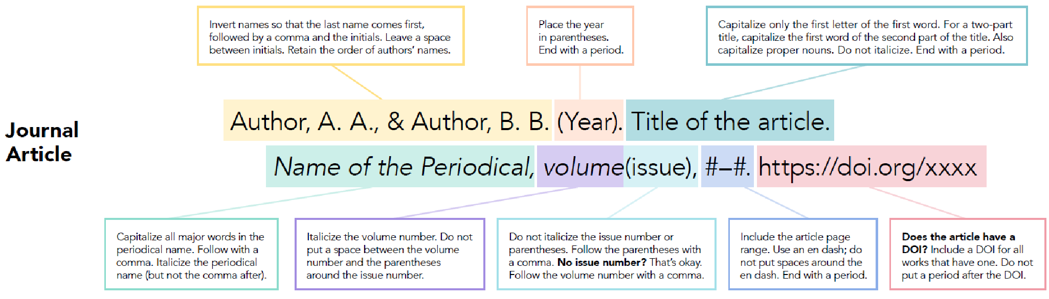

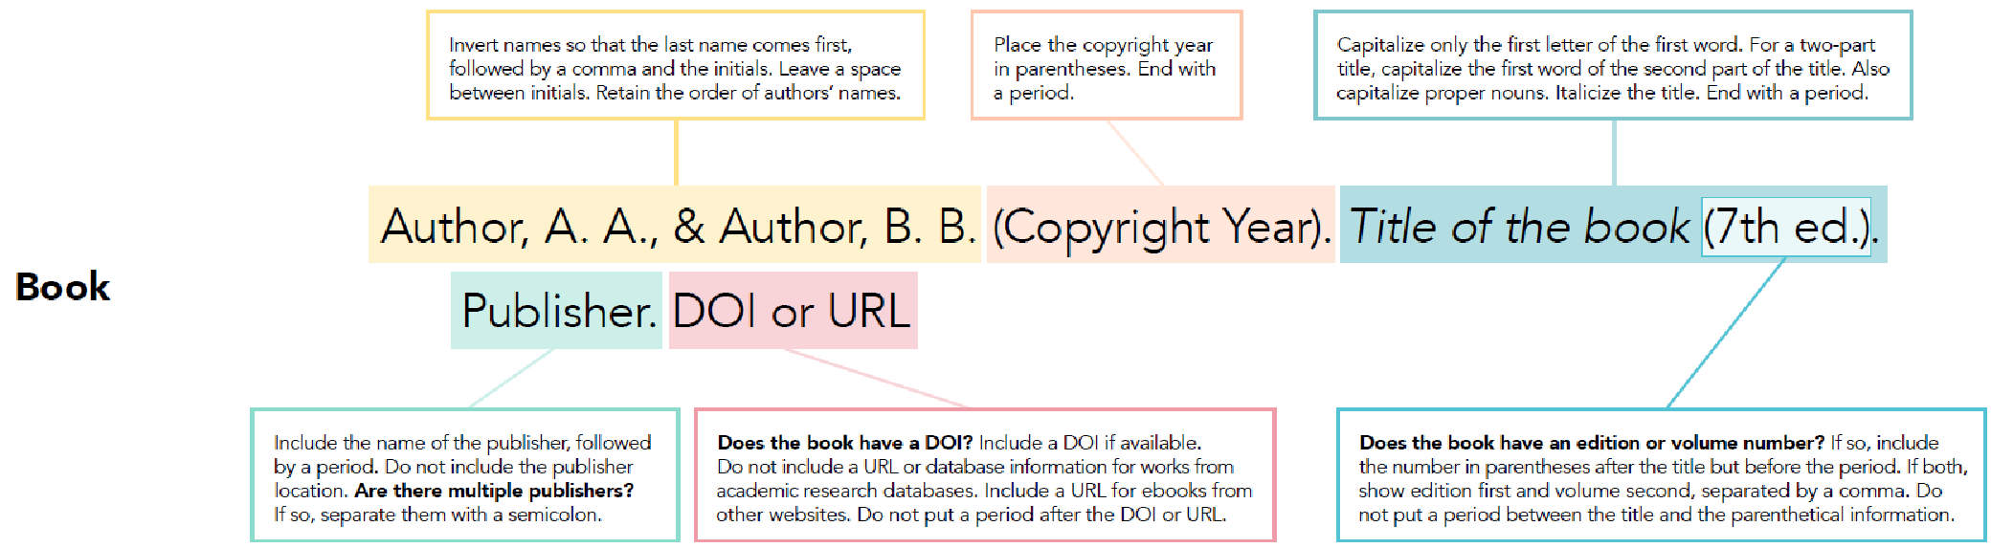

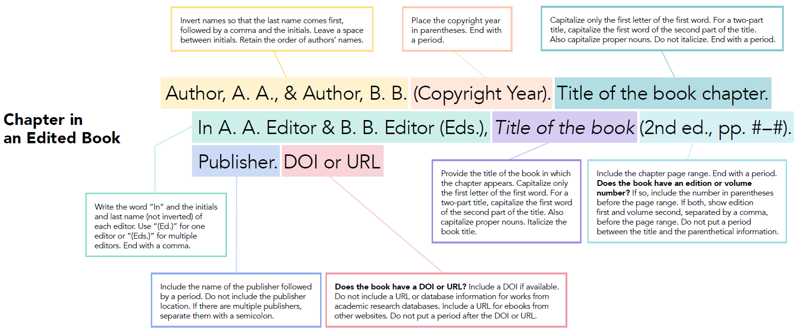

Weitere Beispiele für APA-Richtlinien

Buch
Format
APA 7 | Eintrag im Literaturverzeichnis  primäre Beiträger/-innen (Veröffentlichungsdatum). Titel (Auflage). Herausgeber/-in. DOI  Klammern (primäre Beiträger/-innen, Veröffentlichungsdatum)  Im Fließtext primäre Beiträger/-innen (Veröffentlichungsdatum)
Buch
2. Auflage
1 Autor/-in
DOI

Beispiele
APA 7 | Eintrag im Literaturverzeichnis  Smith, T. (2020). The citation manual for students: A quick guide (2. Aufl.). Wiley. https://doi.org/10.1000/182  Klammern (Smith, 2020)  Im Fließtext Smith (2020)
Buch
2. Auflage
1 Autor/-in
DOI

APA 7 | Eintrag im Literaturverzeichnis  Smith, T. & Williams, B. M. (2020). The citation manual for students: A quick guide (2. Aufl.). Wiley. https://doi.org/10.1000/182  Klammern (Smith & Williams, 2020)  Im Fließtext Smith & Williams (2020)
Buch
2. Auflage
2 Autor/-innen
DOI

APA 7 | Eintrag im Literaturverzeichnis  Smith, T., Williams, B. M. & Streefkerk, R. (2020). The citation manual for students: A quick guide (2. Aufl.). Wiley. https://doi.org/10.1000/182  Klammern (Smith et al., 2020)  Im Fließtext Smith et al. (2020)
Buch
2. Auflage
3 Autor/-innen
DOI

APA 7 | Eintrag im Literaturverzeichnis  Academic Writing Association (2020). The citation manual for students: A quick guide (2. Aufl.). Wiley. https://doi.org/10.1000/182  Klammern (Academic Writing Association, 2020)  Im Fließtext Academic Writing Association (2020)
Buch
2. Auflage
Organisation
DOI

Zeitschriftenartikel

Format
APA 7 | Eintrag im Literaturverzeichnis  primäre Beiträger/-innen (Veröffentlichungsdatum). Titel. Titel des Sammelwerks, Band(Ausgabe), Seitenzahl(en). DOI  Klammern (primäre Beiträger/-innen, Veröffentlichungsdatum)  Im Fließtext primäre Beiträger/-innen (Veröffentlichungsdatum)
Zeitschriftenartikel
2. Auflage
1 Autor/-in
DOI

Beispiele
APA 7 | Eintrag im Literaturverzeichnis  Andreff, W. (2000). The evolving European model of professional sports finance. Journal Of Sports Economics, 1(3), 257–276. https://doi.org/10.1177/152700250000100304  Klammern (Andreff, 2000)  Im Fließtext Andreff (2000)
Zeitschriftenartikel
2. Auflage
1 Autor/-in
DOI

APA 7 | Eintrag im Literaturverzeichnis  Andreff, W. & Staudohar, P. D. (2000). The evolving European model of professional sports finance. Journal Of Sports Economics, 1(3), 257–276. https://doi.org/10.1177/152700250000100304  Klammern (Andreff & Staudohar, 2000)  Im Fließtext Andreff & Staudohar (2000)
Zeitschriftenartikel
2. Auflage
2 Autor/-innen
DOI

APA 7 | Eintrag im Literaturverzeichnis  Andreff, W., Staudohar, P. D. & Streefkerk, R. (2000). The evolving European model of professional sports finance. Journal Of Sports Economics, 1(3), 257–276. https://doi.org/10.1177/152700250000100304  Klammern (Andreff et al., 2000)  Im Fließtext Andreff et al. (2000)
Zeitschriftenartikel
2. Auflage
3 Autor/-innen
DOI

APA 7 | Eintrag im Literaturverzeichnis  Deloitte (2000). The evolving European model of professional sports finance. Journal Of Sports Economics, 1(3), 257–276. https://doi.org/10.1177/152700250000100304  Klammern (Deloitte, 2000)  Im Fließtext Deloitte (2000)
Zeitschriftenartikel
2. Auflage
Organisation
DOI

Zeitungsartikel

Format
APA 7 | Eintrag im Literaturverzeichnis  primäre Beiträger/-innen (Veröffentlichungsdatum). Titel. Titel des Sammelwerks, URL.  Klammern (primäre Beiträger/-innen, Veröffentlichungsdatum)  Im Fließtext primäre Beiträger/-innen (Veröffentlichungsdatum)
Zeitungsartikel
2. Auflage
1 Autor/-in
DOI

Beispiele
APA 7 | Eintrag im Literaturverzeichnis  Popkin, G. (2000). Global warming could unlock carbon from tropical soil. The New York Times. https://www.nytimes.com/2020/08/12/climate/tropical-soils-climate-change.html  Klammern (Popkin, 2000)  Im Fließtext Popkin (2000)
Zeitungsartikel
2. Auflage
1 Autor/-in
DOI

APA 7 | Eintrag im Literaturverzeichnis  Popkin, G. & Draper, K. (2000). Global warming could unlock carbon from tropical soil. The New York Times. https://www.nytimes.com/2020/08/12/climate/tropical-soils-climate-change.html  Klammern (Popkin & Draper, 2000)  Im Fließtext Popkin & Draper (2000)
Zeitungsartikel
2. Auflage
2 Autor/-innen
DOI

APA 7 | Eintrag im Literaturverzeichnis  Popkin, G., Draper, K. & Weed, J. (2000). Global warming could unlock carbon from tropical soil. The New York Times. https://www.nytimes.com/2020/08/12/climate/tropical-soils-climate-change.html  Klammern (Popkin et al., 2000)  Im Fließtext Popkin et al. (2000)
Zeitungsartikel
2. Auflage
3 Autor/-innen
DOI

Appendix

Appendix 1< Title of the first appendix >

Statutory Declaration
In order to circumvent any potential misunderstandings or translation errors, it is imperative that the affidavit be composed in German. The following extract is therefore presented in German:

Eidesstattliche Erklärung
Hiermit versichere ich, dass ich die vorliegende Arbeit selbstständig und ohne unzulässige Hilfe von Dritten sowie unter ausschließlicher Verwendung der angegebenen Hilfsmittel angefertigt habe. Weiterhin habe ich alle von anderen Autoren wortwörtlich übernommenen Stellen sowie die sich an die Gedankengänge anderer Autoren anlehnenden Ausführungen meiner Arbeit gekennzeichnet und die Quellen gemäß den üblichen Standards zitiert. Überdies versichere ich, dass ich diese Arbeit oder nicht zitierte Teile daraus vorher noch in einem anderen Prüfungsverfahren eingereicht habe. Ich bin darüber informiert, dass meine Arbeit einer Überprüfung unterzogen werden kann, um eine etwaige ungekennzeichnete Übernahme fremden geistigen Eigentums zu identifizieren.

Place, date, signature

